1.0 Introduction 1
2.0 Potential Pollution Sources 2
2.1. Applicability 2
2.2. Hydrology 2
2.3. Storm Water Drainage 2
2.4. Significant Spills and Leaks 3
2.5. Cultural Resources 3
3.0 Geology 4
3.1. Wildlife 4
3.2. Soils 4
3.3. Sediment and Erosion Control 4
3.4. Management of Runoff 5
3.5. Acid Rock Drainage 5
4.0 Mining/Reclamation 9
4.1. Financial Assurance 9

Introduction
The Iron Duke Project is a mining/reclamation project being undertaken by Gulf Coast Mining Group, LLC. The Iron Duke Site is located about 35 miles south of Alamogordo, New Mexico in Otero County. The four patented mining claims are contained in Sections 3 and 4 of Township 22S, Range 8E and have a combined area of approximately 75 acres (see Plates 1 and 2). Surface methods will be used to remove historic waste rock dumps from the patented mining claims. The waste rock dumps cover approximately 3.2 acres of the patented claims.
The site is located within the Jarilla Mountains; an isolated uplift near the southern end of the Tularosa Basin floor, The Tularosa Basin is a closed basin measuring about 120 miles north to south and almost 50 miles east to west within the Basin and Range Physiographic Province.
The terrain of the Jarilla Mountains ranges from steep bedrock slopes leading to alluvial drainages and fans at the foot of the mountains. There are no mapped US waters within the drainages containing the site. Closest designated United States waters are separate drainages more than two miles north of the site (Water Canyon on Plate 2).
Because of location, the Iron Duke Project cannot discharge storm water to municipal storm sewer systems or to waters of the United States. According to EPA docket number 833-R-008 dated June 1996, facilities not discharging to municipal storm sewer systems or to waters of the United States do not need a National Pollutant Discharge Elimination System (NPDES) permit. The potential for storm waters to transport sediment from the Iron Duke site during an extreme event prompted Gulf Coast Mining Group, out of good faith, to produce a Storm Water Pollution Prevention Plan (SWPPP). For storm water pollution prevention, this SWPPP was prepared according to applicable EPA regulations and guidance. The plan describes the implementation of practices used to reduce potential pollutants in storm water and ensure permit compliance. As NPDES regulations are revised, changed or superseded, the Gulf Coast Mining Group shall update this plan.

Potential Pollution Sources
This section summarizes the potential pollutant sources at the Iron Duke site. The majority of the site is located in an eastward flowing drainage. A portion of the site, to be mined later, drains to the north and then to the west (see Plate 2 and 3).

Applicability
Land area disturbed at the site for the purpose of removing the rock is between 5 and 10 acres. As the primary activity is removal of non-metallic rock, the site is covered by Section J of the General Permit. Storm water discharges from the areas where materials are exposed to storm water are subject to the requirements of the General Permit.

Hydrology

The Office of the State Engineer lists 4 wells in the general area of the mining/reclamation project (Plate 1). All of these wells are in the aptly named Water Canyon drainage. The OSE database provides a measured depth to water for three of the wells at distances between about 2 miles and 3.5 miles northeast of the site. The depth of water in the closest well is 74 feet. Depths to water at the more distant wells are 70 feet and 400 feet. We conclude that the “shallow” wells are completed within the stream alluvium and fan deposits and the “deep” well accesses a “regional” aquifer. The OSE database does not contain information about the quality of water in these wells.

The patented mining claims are located close to and within the outcropping bedrock of the Jarilla Mountains, the Monzonite Stock (Tm) in Figure 1 (below). Quaternary Alluvium (Q) is mapped east of the patented mining claims and this deposit probably contains limited ground water in the area shown by the blue oval. In our opinion, the Monzonite Stock is not an aquifer and ground water, as defined by New Mexico Regulations, is not present beneath the proposed mining/reclamation project.

Storm Water Drainage
Current and planned activities on the patented claims disturbs about 9.2 acres (Plate 3). Most of this area is contained in an eastward flowing drainage. The remaining portion drains north and then west. These drainages terminate in the closed basin of the Tularosa Valley floor. All storm water runoff from the site will enter one of these drainages (see Plate 1). Storm water run on to the patented mining claims can only occur on the two easternmost claims as the two westernmost claims include the sources of the drainage basins
Of the eastern claims, the northern side of the Virginia claim can have run on from a portion of the basin above the claim. The southern boundary of this claim is formed by a ridgeline leading to a stream bottom. Hence, little to no run on is possible from the south side.
Within the Barbara claim, the principal drainage channel of the basin runs approximately through the middle of the claim. Tributaries from an area larger than this claim feed into this channel from the south and a considerably smaller area drains in from the north. None of this run on is from areas disturbed by activities at the site.
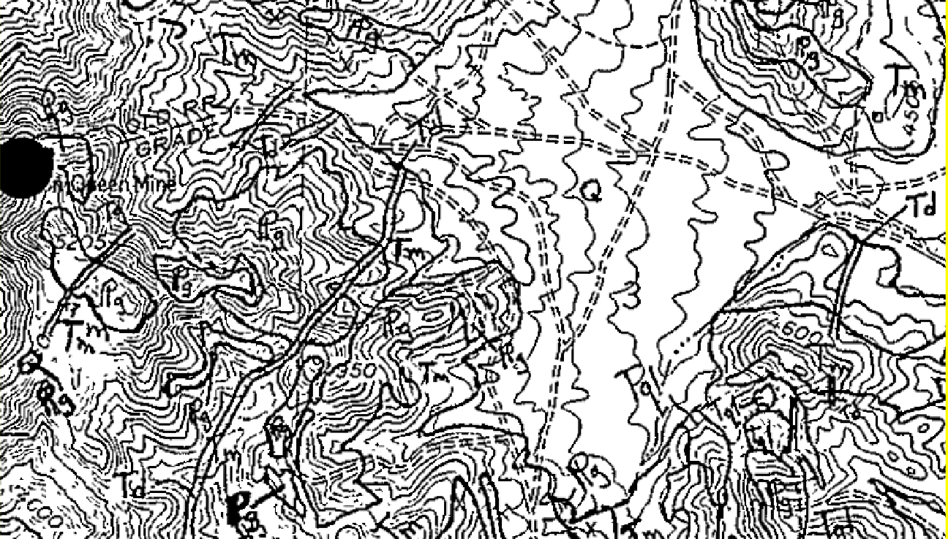

Significant Spills and Leaks
There have been no reportable spills or leaks at the site.

Cultural Resources

Currently, the company is not aware of any cultural resources in the area except for the historic waste rock which was mined in the 19th century.

Geology
Iron Duke Mining Project is part of the Orogrande (Jarilla, Silver Hill) mining district located in the Jarilla Mountains, Otero County, this district is well known as a gold, silver, copper, lead, iron and turquois metallogenetic province and has a past as mining producer of those elements and minerals. New discoveries also determine rich mineralization of PGM’s and Rare Earth elements. Main metallogenic events occur as late-stage veins and limestone replacement deposits in skarns associated with the intrusion of a Tertiary monzonite-quartz monzonite stock complex. Regional Metallogeny shows that Mid-Tertiary alkaline to calc-alkaline rocks are related to seven types of deposits in these districts:
(1) Polymetallic epithermal/mesothermal veins, (2) gold-bearing breccias/quartz veins, (3) Cu-Au, Au and Mo porphyry deposits, (4) Skarns and carbonate hosted deposits, (5) Iron skarns and replacement bodies (with some gold), (6) Gold placers, and (7) Th-REE (with some U, Nb) epithermal veins. Some of New Mexico’s largest gold and REE deposits are found within this belt. Their origin is not well understood, but a compilation of new data (age dates, isotopic and chemical analyses) allows for a better understanding. The diversity of igneous rocks and associated mineral deposits along this belt suggests that this region is characterized by highly fractionated and differentiated; multiple pulses of magmas involve both upper mantle and lower crustal sources. Once magmas and metal rich fluids reached shallow levels, local structures and wall rock compositions determined distribution of and final style of intrusions and resulting mineral deposits (McLemore,2015).

Wildlife
The Iron Duke Mine is home to a variety of wildlife including:
Mule deer usually visit early in the morning or after a rain
Bobcat These cats are also found hunting squirrels in the early evening.
Owls can be seen at night.
Oryx roam all day and night as well as Javelina

Soils
The intent of this reclamation is to re-establish the pre-mining drainage patterns that existed about a century ago. The historic mining activities did not salvage topsoil. The proposed removal of the waste rock dumps will expose the original land surface covered by the dumps about a century ago. We believe the soil thickness of the newly exposed surface will be thin. Many areas beneath the dumps may exhibit no topsoil. Creating new topsoil or preserving any topsoil beneath the historic dumps will be challenging.

Sediment and Erosion Control
The storm water permit requires that areas with a high potential for significant soil erosion be identified and that steps be taken to limit erosion. Features to manage runoff are detailed in the next section.

Management of Runoff
Storm water runoff from the site is managed through installation of the following features.
Pads (and Staging Areas): Each pad and staging area have berms perpendicular to slope every 50 vertical feet. The ends of the berms taper uphill. At the low end of each pad a catchment basin is constructed sufficient to contain 3,600 cubic feet of water per acre of pad. Each basin has an outlet to existing drainage grade. The outlets are lined with country rock derived from the pad construction and readily available country rock from the waste rock piles at the site.
Roads: Roads will be bermed on the downhill side by the grading parallel to direction as practical. The uphill side will be ditched parallel to the road direction for drainage as practical. Bedrock or lack of topsoil at the site does not allow this everywhere. For every 50 vertical feet, a berm will flow laterally from the road surface and perpendicular to the local gradient. Country rock derived from the road and waste rock piles will be used to line the drainage ditching and berms.

Acid Rock Drainage

Tellurium is a chalcophile element found in a variety of mineral deposit types. It tends to form minerals associated with gold, silver, bismuth, copper, lead, and zinc sulfide deposits. Tellurium is one of the few elements that can form a variety of minerals with gold (e.g. calaverite (AuTe2), krennerite ((AuAg)Te2), petzite (Ag3AuTe2) and sylvanite (AgAuTe4)), typically in mineral deposits where gold is the principal economic component.

anomalous concentrations of silver, copper, lead, zinc, tungsten, and tellurium. These deposits also are characterized by anomalous amounts of iron, molybdenum, fluorite, uranium, thorium, rare-earth elements, and niobium. These historic Mine Tailings have high gold/base metal ratios which have been coated and re-coated by various Rare Earth Minerals (REE). Since this area has been coated with various minerals and then encrusted with quartzite.

This phenomenon created a natural weather resistant environment which has contained significant effects of acid rock drainage and the fact that the area is part of the Jarilla Mountains and the Tularosa Basin which contribute to its very arid conditions.

Mining/Reclamation
The Iron Duke project has a North American Industry Classification System (NAICS) code number of 212210 for iron ore mining and an NAICS code 212312 for broken limestone mining and quarrying. For reporting and monitoring requirements, Gulf Coast Mining Group will conduct all monitoring, inspections and reporting required for this industrial classification.
Sediment loading from the mining/reclamation activities is controlled by the following operating procedures.
Slope stabilization and reclamation will occur concurrently with the removal of the waste rock dumps. As the waste rock is removed in approximately 200 by 200-foot sections, large cobbles of country rock will be placed within obvious drainage channels to control erosion. Additionally, at vertical intervals of 50 feet, small berms comprised of country rock cobbles will be anchored in shallow trenches laterally cut across the hill side to slow and dissipate storm water runoff. On the uphill side of these berms, waddles will be staked across the footing of the berm to control movement of fine-grained materials. Country rock aggregate will be left to armor the slopes between the berms as available.
The intent of this reclamation is to re-establish the pre-mining drainage patterns that existed about a century ago before the introduction of the waste rock piles from the historical mining activities.
The area currently is grazed by wildlife. After mining/reclamation is complete, the areas will remain available to wildlife. Reclamation activities will restore the original pre-mining topography to areas outside of the patented mining claims. Pads and roads on the patented mining claims will be re-seeded after the project is complete to minimize erosion and sediment loading to arroyos.

Financial Assurance
As described in the previous amended submittal, the project will remove historic mine dumps and reclaim the hillside beneath the dumps. In order to accomplish the removal, existing roads and former processing pads have been graded and improved to allow movement and placement of equipment. All of the work described in this submittal occurs on patented mining claims except about 1.2 acres of construction that occur on mining claims controlled by the company:

- Lower Iron Duke Pad (0.28 acres) _
- road connecting the Iron Duke pad to the existing road (0.38 acres)
- Improvement and widening of about half of the existing access road to the Iron Duke and Cinco de Mayo claims (about 0.5 acres)
- Improvement of the existing road between the lowermost pad on the Barbara Claim to the pad at the base of the former Railroad Grade (about 0.1 acres)

Reclamation of this one acre of disturbed land on BLM surface consists of re-grading the road and pad to the approximate original condition and re-seeding. Based upon experience with reclamation of similar drilling pads and roads associated with oil and gas exploration, the cost of restoring this one-acre area is about $5,000 the total financial bond in place at this time is $34,282.00.

On the patented mining claims, which are private property, “reclamation” should not be required. Rather:
  - The waste dump removal effort must proceed according to the plan outlined above to minimize contribution of suspended solids to surface waters (arroyos)
  - improved pads must be constructed as proposed above, sloping to small sediment catch basins
  - improvements to the existing roads should include structures to minimize erosion and contribution of sediment to surface waters.

Plates

Area Number | Name of Area | Description | Status | Acres | Amended Additional Area | Area Subtotals
1 | Upper Staging Area | Pads and staging areas | Existing | 0.26
2 | Upper Iron Duke Pad | Pads and staging areas | Existing | 0.20
3 | Bottom Pad (foot of Rail Grade) | Pads and staging areas | Existing | 0.56 | 1.30
4 | Lowermost Pad (on Barbara Patented Claim) | Pads and staging areas | Existing | 0.28 |  | 2.60
5 | Cinco de Mayo Access and Upper Pad | Pads and staging areas | Existing | 0.30 |  | 0.30
6 | Cat Path- Old Rail Grade | Roads and access | Existing | 0.41
7 | Access Road to Iron Duke and Cinco de Mayo | Roads and access | Existing | 1.11
8 | Upper Junction Pad (from head of access road to ID And CdM to Cat Path) | Roads and access | Existing | 0.09
9 | Upper Access Road (From Junction Pad to North Side Waste Rock) | Roads and access | Existing | 0.08
10 | Pad Connecting Road (connects lowermost pad and bottom pad) | Roads and access | Existing | 0.16
11 | Widened Drainage Crossing | Roads and access | Existing | 0.40
12 | Iron Duke Access Road (to Upper pad from north) | Roads and access | Existing | 0.20 |  | 2.45
13 | Iron Duke Waste Rock | Mining/reclamation areas | Historic | 0.90
14 | North Side Waste Rock (Cinco de Mayo and Iron Duke) | Mining/reclamation areas | Historic | 2.27 |  | 3.17
15 | Lower Iron Duke Pad | Pads and staging areas | Existing | 0.28
16 | Access Road to Lower Iron Duke Waste Rock | Roads and access | Existing | 0.38 |  | 0.66
 | Total Area Improved, Reclaimed, Disturbed |  |  | 7.88 |  | 9.18
 |  |  |  |  | Identifiers for Plate 3A | Plate 3B
 |  |  |  |  | Gulf Coast Mining Group, LLC.  Barbara, Cinco de Mayo, Iron Duke, & Virginia MS Claims | April 2025

