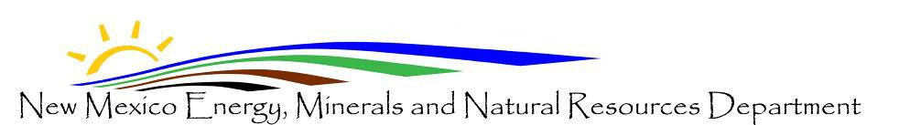
Mining Act Reclamation Program Mining and Minerals Division 1220 South St. Francis Drive Santa Fe, NM 87505 Telephone: (505) 476-3400
Fax No.: (505) 476-3402

MINING ACT RECLAMATION PROGRAM ANNUAL REPORT OF MINING OPERATIONS
The permittee shall submit a report for the preceding calendar year on or before April 30th of each calendar year after a permit has been issued in accordance with the New Mexico Mining Act Rules (the Rules). Data in this report covers activities related to calendar year 2021.
2009 .

Name of Company / Permittee: Permit Number:
Project Name:

Disturbance and Reclamation:
2009
- New acres disturbed during the calendar year (Jan. - Dec.2021 )
Dec. 2009

- Acres reclaimed during calendar year (Jan. -
2021 )

  - Of total acres reclaimed, how many acres were seeded or planted during the previous calendar year (Jan. - Dec. 2021 )
2009
  - Approximate time of year seeded or planted
- Acres released from financial assurance calendar year (Jan. - Dec. 2021)
- Total Cumulative Disturbed Acreage (all years)
- Total Cumulative Reclaimed Acreage (all years)

If new disturbance has occurred, or reclamation conducted, during calendar year 2021
2009
, maps must be

provided with this annual report, identifying the location of the disturbed areas and/or areas of reclaimed land and the year in which the work was done. If possible, please provide these maps in electronic format. For smaller sites (< 10 acres), pdf format is acceptable; however, for larger sites (> 10 acres), dwg format is preferred. If you are going to use dwg format, please contact the permit lead prior to discuss the type of projection and coordinate system you will be using. Note: Submitting hard copies of this form and any related maps is still acceptable.

Financial Assurance (Collateral-Real Property Only):
Indicate the current market value of any collateral (real property only) posted as financial assurance in accordance with
19.10.12 NMAC.

Compliance Status:
Indicate compliance status for all existing State and Federal environmental permits held by the permittee for this operation.

Permit No. Permit Name Issuing Agency Status Expiration Date

I hereby affirm that the information provided is true, complete and correct.

Signature Date

For electronic submittals: By typing your name on the signature line, you acknowledge that you are submitting this as an electronic signature. The Mining Act Reclamation Program accepts your annual report digitally in lieu of receiving your annual report by U.S. Mail or by fax.

PLEASE COMPLETE THE FOLLOWING LEGIBLY:
Name: Title:
Email address: Phone number:

Company Name: Address:

Fax number:

