State of New Mexico
Energy, Minerals and Natural Resources Department

Michelle Lujan Grisham
Governor

Melanie A. Kenderdine
Cabinet Secretary

Benjamin Shelton
Deputy Cabinet Secretary

Erin Taylor
Deputy Cabinet Secretary

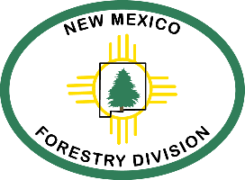

Laura McCarthy, State Forester
Forestry Division

Fire Restrictions Exceptions Procedures

For the State Forester to consider an exception to the State of New Mexico’s Smoking, Firework, Campfire, and Open Fire Restrictions 2025-01 to conduct an open fire activity on non-municipal, non-federal, and non-tribal lands statewide, you must provide the following information in your emailed request:

• Landowner’s or Operator’s name
• Name and contact information of person in charge of conducting, monitoring and maintaining control of an exception to the fire restriction
• Number of personnel on site to monitor and maintain control
• Location of open fire activity including: address, latitude and longitude, township and range, and county if available
• Firefighting and fire mitigation equipment on site during the open fire activity, if applicable
• How you will notify the local fire department and Forestry Division before ignition.

The amount and accuracy of the information that you provide will be beneficial in providing a timely response to your exception request.

If you have any questions or are requesting an exception, please email and carbon copy or telephone the following individuals:

Lindsey Quam Lindsey.Quam@emnrd.nm.gov (505) 490-0827
Vernon Muller VernonJ.Muller@emnrd.nm.gov (505) 690-1069
Robert Brown Robert.Brown@emnrd.nm.gov (505) 660-5705
George Ducker George.Ducker@emnrd.nm.gov (505) 690-8210

