Forest Stewardship Plan | Tree Farm Management Plan | NRCS Forest Management Plan
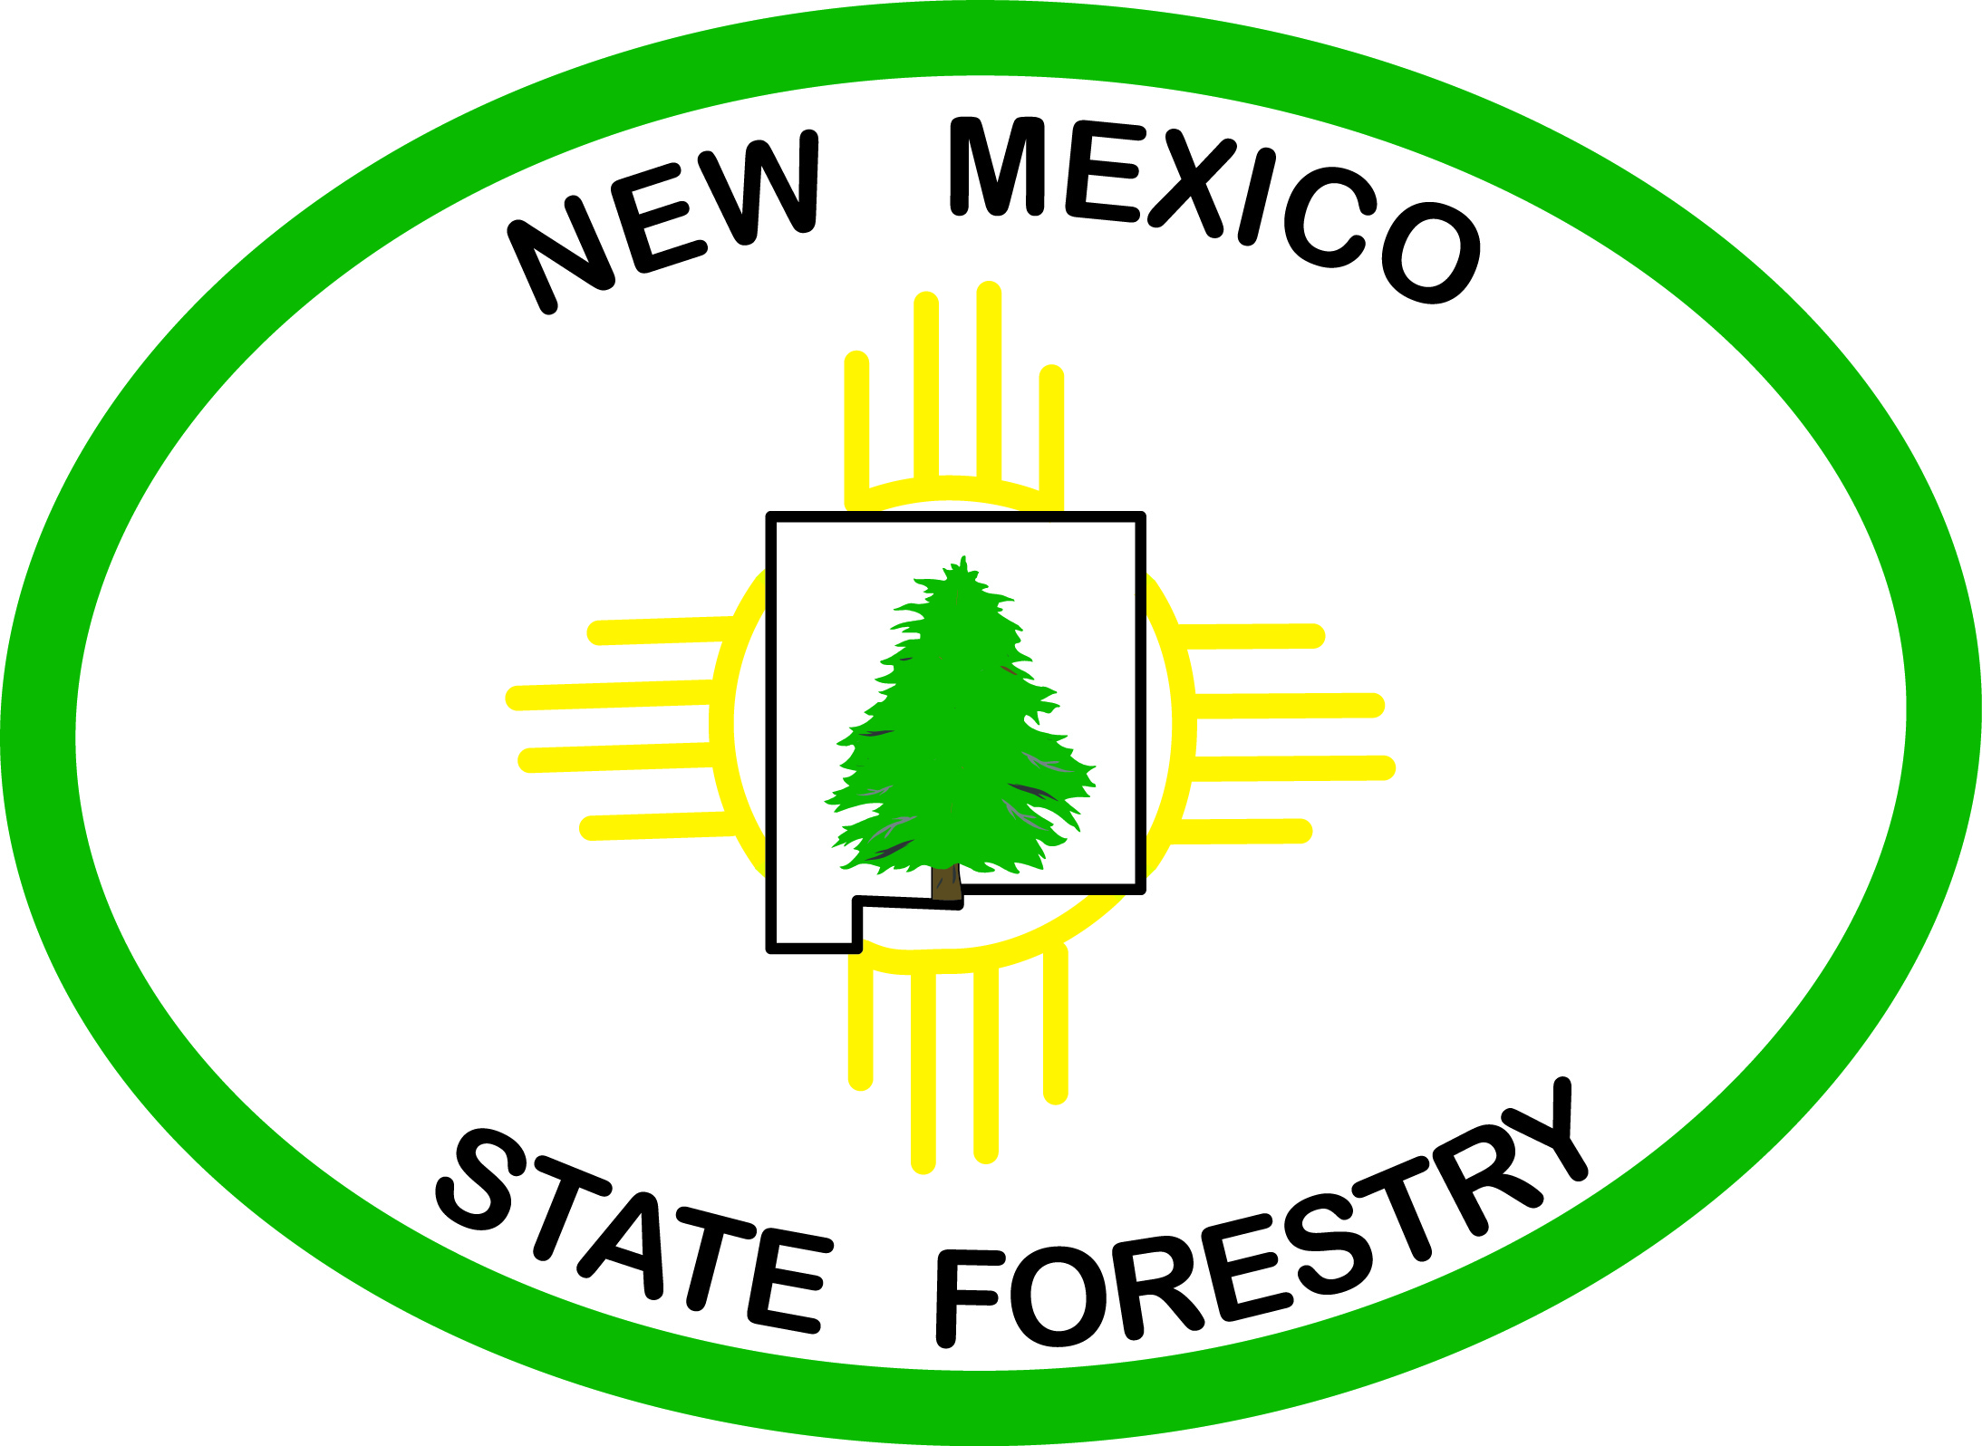
Landowner Management Plan



PURPOSE
This document is intended to describe the minimum criteria needed for a forest management or stewardship plan. These criteria align with national standards set forth by the USDA – Forest Service Stewardship Program. These criteria are consistent with Tree Farm management plans and the technical criteria of the USDA – Natural Resources Conservation Service’s Conservation Activity Plans.
The landowner should provide input to any and all sections they feel comfortable researching, but especially Sections I and II. A forester or qualified natural resource professional must complete Sections III, IV, and V with input and feedback from the landowner.

Disclaimer: Signing this document does not obligate the landowner to complete specific practices described in the document.

HOW TO EDIT THIS DOCUMENT
This document has been created as a Word 2007 “Fillable Form” to allow for more security and a cleaner look when a resource professional gives the template to a landowner.
The template can and should be edited outside of “Fillable Form” mode by the resource professional to tailor it to the specific needs of the planner and the landowner.
TABLE OF CONTENTS
Section I.
PROPERTY OWNER(S) | Page
PROPERTY LOCATION AND RESIDENCY STATUS | Page
RECORD VERIFICATION | Page
PROPERTY HISTORY/DESCRIPTION | Page
LANDOWNER GOALS AND OBJECTIVES | Page
PROPERTY MAPS | Page
Section II.
PROPERTY CHARACTERISTICS | Page
FISH AND WILDLIFE | Page
THREATENED AND ENDANGERED SPECIES | Page
RARE PLANTS | Page
SOIL AND WATER RESOURCES | Page
RECREATION AND AESTHETIC RESOURCES | Page
ROADS AND ACCESS | Page
SPECIAL SITES AND CONSIDERATIONS | Page
ADDITIONAL LANDOWNER OBSERVATIONS | Page
DISEASE/INSECT/DAMAGE | Page
WILDLIFE TREES and PILES | Page
Section III. TIMBER INVENTORY AND FOREST RESOURCE ASSESSMENT | Page
Section IV. FOREST PROTECTION | Page
FOREST INSECTS AND DISEASES | Page
FIRE HAZARD | Page
NOXIOUS WEEDS | Page
CULTURAL RESOURCES | Page
Section V. MANAGEMENT RECOMMENDATIONS | Page
POTENTIAL ISSUES | Page
SIGNATURE PAGE | Page
WORKS CITED | Page
APPENDICES | Page
Section I. PROPERTY DESCRIPTION
PROPERTY OWNER(S)
Landowner (s) or Representative:
Mailing Address:
Phone: ( ) - E-Mail:
Plan Completion Date: Revision date (5-yr cycle) No.
PROPERTY LOCATION AND RESIDENCY STATUS
Legal description: (Township, Range, Section, Quarter Section and Latitude, Longitude in Decimal Degrees)
Closest city/town/landmark: County:
Total Acreage: Total Forested Acres:
Is there a residence or structure(s) on the property? Yes No
Do you reside on the property? Yes No Year-round? Yes

RECORD VERIFICATION
Advisor Name: Phone: ( ) -
District: Date of Visit: # Acres Verified
Approved By (TMO/DF/DC) (Signature):
Landowner(s)/Representative Signature(s):

PROPERTY HISTORY/DESCRIPTION
Provide a brief description of the property, known management activities now and in the past, development of the ownership, known background information of property. (500 words)

LANDOWNER GOALS AND OBJECTIVES
List the primary goals and objectives of the landowner. Keep in mind the size and type of harvest, and the effects of harvest on residual forest, wildlife, water resources, and vegetation. Also consider what type of forest or landscape will result after a harvest, and how will this affect reforestation and future management? Always keep in mind long term effects.
A) Ex. Goal 1 - Protect water quality in all watercourses.
Objective 1.1 - reduce soil erosion by improving herbaceous cover
Objective 1.2 - use existing material and resources to construct appropriate erosion control structures
Objective 1.3 - maintain healthy riparian forest buffers
B)
C)
D)
E)

PROPERTY MAPS
Attach Property Map Here – Topographic maps and aerial photos are preferred. Free downloads of aerial/orthophotos are available at: http://earth.google.com.
Identify: 1) title, 2) author, 3) property boundary, 4) management area(s), 5) include map scale (e.g. 1” = 200’), 6) directional arrow (indicating north), 7) a legend identifying homes or structures, water-ways or water sources, and roads or tracks

Section II. RESOURCE DESCRIPTIONS
Gathering solid information in the field (through surveys, inventory, etc.) and from printed or online resources is critical for this section. The plan writer will pair the landowner’s goals and objectives from Section I with the resource information in Section II to provide management recommendations in Section V.
PROPERTY CHARACTERISTICS
GENERAL PROPERTY CHARACTERISTICS
Use the Comprehensive Wildlife Conservation Strategy (http://fws-case-12.nmsu.edu/cwcs/index.php) or other resources (reGAP data layers) to identify and describe the ecoregion and other relevant features.

FISH AND WILDLIFE
Fish & Wildlife Species: (List species on-site and add an appendix for species found in the county (www.BISON-M.com). Consider practices that might improve or create habitat. Use the Comprehensive Wildlife Conservation Strategy (http://fws-nmcfwru.nmsu.edu/cwcs/New_Mexico_CWCS.htm) to determine potential species of concern and list them here.

Habitat Type: (What species are being targeted? How does this affect other resources? Use BISON-M to assess species requirements. (See above.)

Hunting: (Is there hunting on the property? What type of hunting? How are you going to manage resources, waterways, access, noxious weeds that might be brought in, and long-term population viability?)

THREATENED AND ENDANGERED SPECIES
Use the link to learn about state listed, or federally listed threatened and endangered wildlife species and their habitats. Use the link to run a report for “County-Federal/State Status” http://bison-m.org/speciesreports.aspx and copy and paste appropriate species likely to be found on the property in this section.

RARE PLANTS
Use the link to learn about rare plants in your county. You may include a comprehensive list in the appendix, and in this section make note of the specific species that you find on your property. http://nmrareplants.unm.edu/

SOIL AND WATER RESOURCES
Use http://websoilsurvey.nrcs.usda.gov/app/HomePage.htm or Soil Data Mart to create an Area of Interest and summarize soils data. Include maps of soil types and properties of each major soil, and identify any wetlands or riparian zones. Specify whether or not soil erosion is a resource concern or potential issue based on soils reports and visual assessment.

RECREATION AND AESTHETIC RESOURCES
Describe what opportunities exist for recreation on the property, and how aesthetics may factor in to management alternatives.

ROADS AND ACCESS
Are there access issues on the property? Will you allow access to and across your property? Are property boundaries identified? Who do you share boundaries with? Are there units or stands that are best accessed through other private or public lands? Will any Forest Service, BLM, or county roads be used for access? Do you need a permit?

SPECIAL SITES AND CONSIDERATIONS
Provide information on any areas of special interest – biological, geological, ecological, etc.

Nearby units or adjacent ownership concerns: How might treatments impact these areas and your neighbors? Consider aesthetics, wildlife, privacy, and exotic or noxious weed control.

ADDITIONAL LANDOWNER OBSERVATIONS
DISEASE/INSECT/DAMAGE
Detail the symptoms such as foliage color, pitching out, etc. as well as tree species affected, and approximate location of affected area. (NOTE: Pictures below are copied from the Field Guide to Insects and Diseases of Arizona and New Mexico – Region 3.)

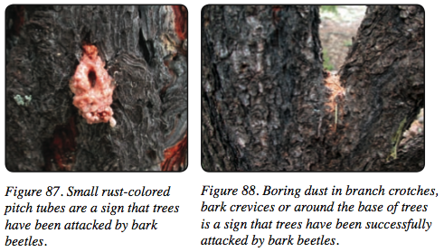
Bark beetle attack:

Pitch flow (new or old):

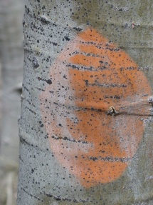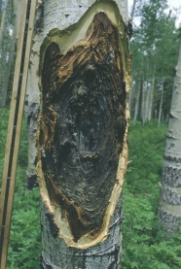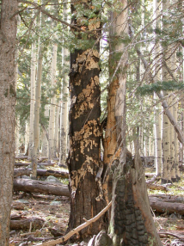
Cankers:

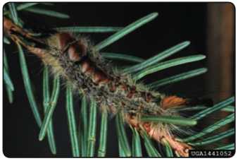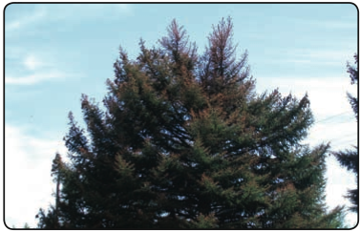
Defoliators:

Stem or branch damage:

Visible rot/decay (root/butt):

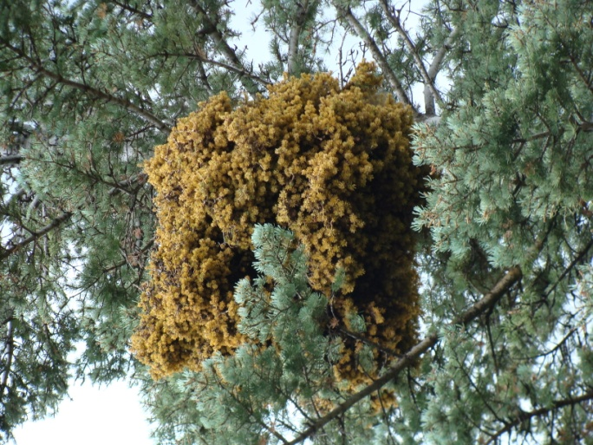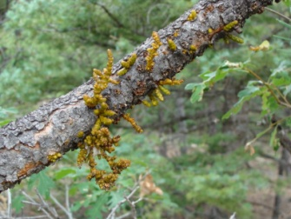
Mistletoe/Broom rust:

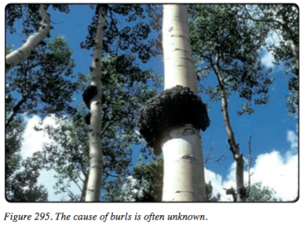
Galls on trunk:

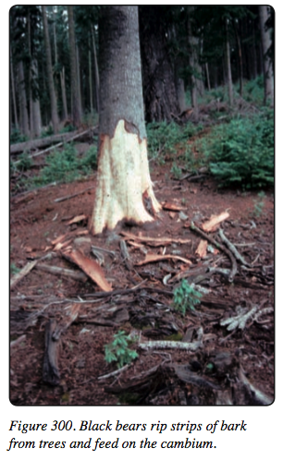
Animal damage:

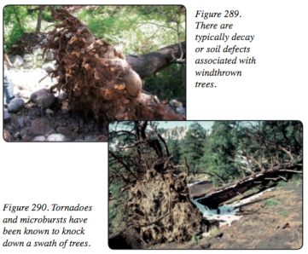
Wind-throw:
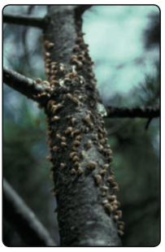White Pine Blister Rust
Rust:

Other:

WILDLIFE TREES and PILES
(Are there snags and roost trees on the property? Can they be created? Nests may need to be flagged to avoid. Wildlife piles can be created with slash for smaller critters.)
Roost tree groups:
Nests: (squirrels, owls, birds, etc.)
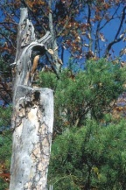
Snags:
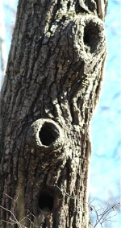
Cavity trees:

Things to keep in mind before implementing the treatments discussed in upcoming sections:

Are you harvesting (selling material) from an area > 25 acres per year (commercial timber) or from an area > 75 acres per year (fuel wood)?
Yes → You need a harvest permit No → You need to follow best management practices

Are you applying for cost-share assistance or payment incentives from a government program?
Consult Appendix B for brief summaries of some relevant programs. If you are applying for a program you should consult your local Forestry Division district staff for technical advice and to complete practice plans or job sheets. This Management Plan should greatly assist in the process.
Section III. TIMBER INVENTORY AND FOREST RESOURCE ASSESSMENT
An inventory must be conducted using variable or fixed radius plots to capture the range of variability. Inventory data must be summarized electronically and tables and/or charts provided within this section. Data should include species present, current stocking levels (square feet of basal area per acre, trees per acre, and average diameter), and size class distribution.
Additional data that could be gathered includes:
    - Site index (where merchantable species exist and timber production is a goal)
    - Shrub or other understory species lists (or % cover)
    - Downed woody debris (assessed through Brown’s transects or visual estimates) in pounds per acre and identify whether these rates are high, moderate, or low.
Consider using a summary table as seen below.
 | Current Conditions | Target
BA (sq ft) |  | -
TPA |  | -
Avg Diam. | inches | + inches

If appropriate, use the following UNIT format to describe the property, or describe the property as one large unit.
UNITS
For each stand or unit please name the unit, list appropriate management objectives, and provide a short narrative of the unit and the current condition it is in. Then fill in the remaining boxes. A stand or unit can be designated by changes in species composition (grasses and shrub to timber), topographical features, fence-lines, roads, or other features disrupting forest continuity. If there is more than one unit, copy and paste the entire template for Unit 1 and rename it Unit 3, and fill it out.
Number of stands or management unit’s
Unit 1: Acres
Objectives:
Description:
Aspect (check all that apply): N S E W Avg. Elevation:
Topography (check all that apply): flat hills arroyos steep-slopes dips
Grade (estimate % of property in each category):
Flat: % Gentle Slope <20%: % Steep Slope (>20%): %
Accessibility by Vehicle: (What percent of the area is in each of the following categories?)
Excellent (80% accessible) % Good (50%) %
Fair (25%) % Poor (less than 10%) %
Estimated road length (drivable):
Streams on-site (circle): YES NO How many?
Type (check): Perennial (flows year round) Intermittent (flows part of the year) Ephemeral (flows in response to precipitation events)
Seeps or springs on-site: YES NO How many?

Unit 2: Acres
Objectives:
Description:
Aspect (check all that apply): N S E W Avg. Elevation:
Topography (check all that apply): flat hills arroyos steep-slopes dips
Grade (estimate % of property in each category):
Flat: % Gentle Slope <20%: % Steep Slope (>20%): %
Accessibility by Vehicle: (What percent of the area is in each of the following categories?)
Excellent (80% accessible) % Good (50%) %
Fair (25%) % Poor (less than 10%) %
Estimated road length (drivable):
Streams on-site (circle): YES NO How many?
Type (check): Perennial (flows year round) Intermittent (flows part of the year) Ephemeral (flows in response to precipitation events)
Seeps or springs on-site: YES NO How many?

Section IV. FOREST PROTECTION
FOREST INSECTS AND DISEASES: (Consult the Field Guide to Insects & Diseases of Arizona and New Mexico (http://www.fs.fed.us/r3/resources/health/field-guide/index.shtml) to identify common pests found on the property and discuss management techniques to mitigate their impact in Section 3).

FIRE HAZARD:
Discuss fuel loading, fire regime characteristics, etc. using the check-boxes below. Measure fuel loading using Brown’s transects, photoloads, or other scientifically proven methods.

Ladder fuels High – touching lowest branches of tree
Medium – 1 foot below lowest branch
Low - < 1 foot below lowest branch

Crowns touching High – crowns touching or interlocking
Medium – 10’ – 15’ crown spacing
Low - <20’ crown spacing

Fuels Fine fuels (grasses taller 1’, >2” needle depth, brush, branch cover)
High Medium Low

Heavy Fuels (branches > 2” diameter, logs, slash depth > 2’)
High Medium Low

Continuity of ground fuels
High – touching Medium – some touching Low – rare touching

Total fire risk (total from all categories)
High – more than two H Moderate – two or more M Low – one M or less

List which Community Wildfire Protection Plan includes the area addressed in this management plan and name the nearest community (or communities) from the latest list of Communities at Risk that this plan has the potential to impact. (http://www.emnrd.state.nm.us/fd/firemgt/cwpps.htm

Assess any structures on the property and provide defensible space guidelines http://www.emnrd.state.nm.us/FD/FireMgt/FirePreventionandOutreachProgram.htm

Describe other fire hazard issues and concerns.

NOXIOUS WEEDS:
Run a database query (http://weeds.nmsu.edu/) for Class A, B, and C noxious (non-native, invasive) weeds found in the county. Insert a list of potential weeds in the county in this section and a state-wide list in the appendix.

When entering and leaving a site, be sure to clean vehicle tires and tracks to wash off seeds. Be prepared to see weeds along skid trails and roads, and treat them as soon as possible. In many cases, noxious weeds sprout from any portion of the root and thus, herbicide is required to avoid resprouting. A landowner does not need a permit to spray herbicides on their own property unless it is a “classified” substance. (Consult the New Mexico Department of Agriculture’s website at: http://www.nmda.nmsu.edu/pesticides/).

CULTURAL RESOURCES
Any known resources must be identified and should be described. A report must be run through the State Historic Preservation Office to determine what registered sites are already known. (NMSF will provide this SHPO report.) Appropriate measures must be taken to avoid disturbing any sites during management activities, especially where federal dollars are spent.

Section V. MANAGEMENT RECOMMENDATIONS
This section will detail how the landowner should go about implementing this Plan. A qualified forester should fill out this section after discussing alternatives with the landowner. The better detailed this section is, the easier it should be for a landowner to obtain cost-share / payment incentives. (Reference Appendix C)
POTENTIAL ISSUES
To consider and address:
- Erosion mitigation measures (e.g. Zeedyck structures)
- Integrated pest management
- Noxious weed control
- Reforestation
- Understory species management/course woody debris recruitment. (Discuss grasses, forbs, shrubs, seedlings, logs, slash, and chips)
- Grass Management / Grazing Management. (Consult the NRCS’ guidelines for grazing management conservation activity plans at http://www.nm.nrcs.usda.gov/technical/fotg/section-3/captc.html).
- Prescribed burning. (Consider burning slash piles after treatment, and broadcast burning to restore a natural fire regime for appropriate forest systems such as ponderosa pine.)
- Climate change adaptation and mitigation
  - Include management regimes that will maintain and enhance forest carbon sequestration and cycling capacity.
  - Consider possible near and long-term impacts of climate change, including drought induced increased fire risk, invasive species migration, and species range/habitat shifts.
- Water quality and supply
  - Emphasize the importance of forest management and conservation in high priority watersheds identified in national, regional, and state resource assessments.
    - The NM State Forestry Statewide Assessment is found at: http://www.emnrd.state.nm.us/FD/StatewideAssessment.htm
Provide an action plan or schedule of operations for planned activities in the near term (i.e. 1-5 years). (See “Plan Implementation Schedule” below.)
For the Landowner – Management considerations:
What do you plan to accomplish? What are the goals, planned treatments, monitoring plan, protection from fire or insects or disease, anticipated end results.
When will treatment be conducted? How will it be maintained?
Where will treatment occur? In what unit(s), near what resources?
How will treatment affect other nearby areas and resources? How will treatment be accomplished? What type of equipment will be used?
Who will conduct the treatment(s)?

DESIRED FUTURE CONDITION
Record this information on a per Unit/Stand basis.

Current Forest Structure & Desired Forest Structure (check all that apply for current condition, “X” all that apply for the desired condition):

Overgrown Even-age 2 story multi-story

Low growth max. growth growth+regeneration some growth &
potential + low regeneration &
wildlife use wildlife use

Desired Residual Basal Area, Tree Spacing (feet-groups or clumps), and Trees per Acre
This is on a per unit basis. Use inventory data from Section 2 and the tables below to develop these recommendations.
 | Current Conditions | Target | Remove
BA (sq ft) |  | - | 00-00
TPA |  | - | 00-00
Avg Diam. | inches | + inches | -----------

Basal Area: square feet per acre
Spacing: Large (>9”DBH) (ft) Pole (5-8”DBH) ______ (ft) Seedling (<5”DBH) _____ (ft)
Trees per Acre:
Openings (if desired) – Size and Shape:

BASAL AREA SPACING GUIDE
Residual | Square Ft. of Basal Area Per Acre
DBH | 40 | 50 | 60 | 70 | 80 | 90 | 100 | 110 | 120 | 140
Inches | Square Spacing to Nearest Foot
2 | 5 | 4 | 4 | 4 | 3 | 3 | 3 | 3 | 3 | 3
4 | 10 | 9 | 8 | 7 | 7 | 6 | 6 | 6 | 6 | 5
6 | 15 | 13 | 12 | 11 | 10 | 10 | 9 | 9 | 8 | 8
8 | 19 | 17 | 16 | 15 | 14 | 13 | 12 | 12 | 11 | 10
10 | 24 | 22 | 20 | 18 | 17 | 16 | 15 | 15 | 14 | 13
12 | 29 | 26 | 24 | 21 | 21 | 19 | 18 | 18 | 17 | 16
14 | 34 | 31 | 28 | 26 | 24 | 23 | 22 | 21 | 20 | 18
16 | 39 | 35 | 32 | 29 | 28 | 26 | 25 | 24 | 24 | 21
18 | 44 | 39 | 36 | 33 | 31 | 29 | 28 | 26 | 25 | 23
20 | 49 | 44 | 40 | 37 | 34 | 32 | 31 | 29 | 28 | 26
BASAL AREA to TPA - STOCKING GUIDE
 | Square Ft. of Basal Area Per Acre
DBH | 40 | 50 | 60 | 70 | 80 | 90 | 100
(In) | Number of Trees Per Acre
2 | 1834 | 2292 | 2750 | 3209 | 3667 | 4125 | 4584
4 | 458 | 573 | 688 | 802 | 917 | 1031 | 1146
6 | 204 | 255 | 306 | 357 | 407 | 458 | 509
8 | 115 | 143 | 172 | 201 | 229 | 258 | 286
10 | 73 | 92 | 110 | 128 | 147 | 165 | 183
12 | 51 | 64 | 76 | 89 | 102 | 115 | 127
14 | 37 | 47 | 56 | 65 | 75 | 84 | 94
16 | 29 | 36 | 43 | 50 | 57 | 64 | 72
How to use this table: If your trees are about 8” in diameter at breast height and you want to stock your land at 60 square feet of basal area per acre, you would have about 170 trees per acre.
How to use this table: If your trees are about 8” in diameter at breast height and you want to stock your land at 60 square feet of basal area per acre, your spacing would be 16’ X 16’.

FOREST PRACTICES
(Define the units where practices will occur and depict on map. If prescribed burning will occur, attach a burn plan and define containment resources and contingency plans.)

Harvesting Activities: (describe the type, residual forest after activity, methods, time frame, and time of year)

Slash management: (lop and scatter, pile, whole tree, chip, mulch, leave woody debris, whole tree woody debris, broadcast burning)

Post harvest: (slash burning, re-seeding trails + landings, weed control, erosion)

Streamside/Riparian Management: (is wetland or stream in harvest area marked, are Best Management Practices in place and being followed?)

Monitoring: (how often will the management areas be evaluated to ensure success or failure; re-treatment?)

Plan implementation schedule: Indicate the type of treatment, time of year, # of acres, unit, etc. (See below for a list of NRCS forestry practices. Consult the Field Office Technical Guide for a complete list of practices at http://www.nm.nrcs.usda.gov/technical/fotg/section-4/std-specs.html)

Year 1:

Year 2-3::

Year 4-5:

Year 5 +:

Cost-share used? What type?

ROADS, SOIL, WATER – Best Management Practices
Do you have goals to protect or conserve your forest’s roads, soil, and water resources? What steps will you take to ensure protection?

Soil conservation: (consider: steep slopes, woody material retention, vehicle traffic, compaction from activities, run-off, livestock or wildlife issues)

Soil Characteristics: Use the NRCS’ Web Soil Survey (http://websoilsurvey.nrcs.usda.gov/app/WebSoilSurvey.aspx) to research soil survey information for your property. The report generated should be included as an appendix.

Textures may be a combination of several types. (Check all that apply.)
rocky gravel silt sandy clay bedrock
Discuss which types are found on which units:

Depth: deep soils (>2 feet) Which unit(s)?
shallow (<2 feet)

Drainage: well draining poor drainage ponding channel cutting

Other:

Roads: (Consider maintenance, erosion potential, condition, run-off, drainage, water-way crossing, culverts, weed control, time of year use, Best Management Practices.)

Streamside Management
Area Guide
% Slope (above stream) | Buffer Strip Width* (ft)
0 | 50
10 | 70
20 | 90
30 | 110
40 | 130
50 | 160
60 | 180
70 | 200
*Measured as horizontal distance.
Road/Trail Drainage Guide
Minimum legal requirements, spacing between water bars by % grade
% Grade | Distance* (ft)
0 -4.9 | 150
5.0-9.9 | 130
10.0-14.9 | 75
15.0-24.9 | 50
25.0-40 | 25
*Measured on/along
road slope. More specific data dependent on aspect , parent material, and slope location found in Forest Practice Guidelines.

Streams, ponds, wetlands, and springs, seeps: (Consider protecting any Streamside Management Area or wetlands, possible permits from the NM Environment Department, wildlife habitat, road crossings, vicinity to activities, impacts by activities, etc. Consult the New Mexico Forest Practice Guidelines at http://www.emnrd.state.nm.us/FD/ForestMgt/ForestMgt.htm).

SIGNATURE PAGE
Landowner Signature

Name Date

Plan Author Signature

Name Date

Approving Authority Signature (NM State Forestry, NRCS, or Tree Farm representative):

Name Date

WORKS CITED
Encyclopedia Britannica Online 2010, www.brittanica.com

Forest Directory by Subject Online 2010, www.foresters.org/subject/

Society of American Foresters Dictionary website 2010, http://www.dictionaryofforestry.org/

New Mexico State Forestry: Harvest Practices Guidelines, 2008

2010 –2015 American Tree Farm System Standards of Sustainability, http://www.treefarmsystem.org/cms/pages/26_130.html

Montana Department of Natural Resources and Conservation, 2010

Montana State University Extension Forestry, 2010

APPENDICES
(Note: The plan writer should add as many appendices as are necessary for the landowner’s needs. Right click to add more rows to the table below.)
Appendix A | NRCS Forest Practices
Appendix B | Cost-Share Programs
Appendix C | Useful Definitions
Appendix D | Noxious Weeds List
Appendix E | Useful Websites

APPENDIX A
NRCS Forest Practice List
(not comprehensive of all NRCS practices)
Access Control (472) - The temporary or permanent exclusion of animals, people, vehicles, and/or equipment from an area.
Forest Stand Improvement (666) - The manipulation of species composition, stand structure, and stocking by cutting or killing selected trees and understory vegetation.
Road/Trail/Landing Closure and Treatment (654) (yet to be updated to NM-NRCS website)
Forest Trails and Landings (655) - A temporary or infrequently used route, path or cleared area within a forest.
Forest Slash Treatment (384) - Treating woody plant residues created during forestry, agroforestry, and horticultural activities to achieve management objectives.
Firebreak (394) – A permanent or temporary strip of bare land or vegetated land planned to retard fire.
Fuel Break (383) - A strip or block of land on which the vegetation, debris and detritus have been reduced and/or modified to control or diminish the risk of the spread of fire crossing the strip or block of land.
Multi-Story Cropping (379) - Existing or planted stands of trees or shrubs that are managed as an overstory with an understory of woody and/or non-woody plants that are grown for a variety of products.
Prescribed Burning (338) - Applying controlled fire to predetermined area.
Riparian Forest Buffer (391) - An area, predominantly trees and/or shrubs, located adjacent to and up-gradient from watercourses or water bodies.
Silvopasture Establishment (791) - An agroforestry application establishing a combination of trees or shrubs and compatible forages on the same acreage.
Tree/Shrub Site Preparation (490) - Treatment of areas to improve site conditions for establishing trees and /or shrubs.
Tree/Shrub Establishment (612) - Establishing woody plants by planting seedlings or cuttings, direct seeding, or natural regeneration.
Tree/Shrub Pruning (660) - The removal of all or part of selected branches, leaders or roots from trees and shrubs.
Alley Cropping (311) - Trees or shrubs are planted in sets of single or multiple rows with agronomic, horticultural crops or forages produced in the alleys between the sets of woody plants that produce additional products.
Windbreak/Shelterbelt Establishment (380) - Linear plantings of single or multiple rows of trees or shrubs or sets of linear plantings.
Windbreak/Shelterbelt Renovation (650) - Replacing, releasing, and/or removing selected trees and shrubs or rows within an existing windbreak or shelterbelt or adding rows to the windbreak or shelterbelt.

APPENDIX B
Cost-Share and Payment Incentive Programs
Participation in these programs is entirely voluntary. Information below is for guidance only.

USDA
The following additional guidance is provided for those who intend to use Forest Stewardship Plans to satisfy USDA Conservation Program requirements in order to receive cost-share assistance for plan implementation. The guidance is intended to expedite and facilitate participation in USDA cost-share programs when requested by the forest landowner.

The 2008 Farm Bill explicitly allows participation by non-industrial private forest landowners in many USDA conservation programs, which are administered by the Natural Resources Conservation Service (NRCS) and/or Farm Service Agency (FSA). Eligible NIPF landowners may then be able to apply for a wide range of cost share assistance to implement their FSMP through these and other programs:

NRCS programs: (http://www.nm.nrcs.usda.gov/programs/)
- Environmental Quality Incentives Program (EQIP)
- Wildlife Habitat Incentives Program (WHIP)
- Conservation Stewardship Program (CSP)
- Healthy Forests Reserve Program (HFRP)¹
¹ AGI limitation does not apply to HFRP. HFRP is only available in a limited number of states.

FSA programs: (http://www.fsa.usda.gov)
- Conservation Reserve Program (CRP)
- Emergency Forest Restoration Program (EFRP)
- Biomass Crop Assistance Program (BCAP)

Fish and Wildlife Cost-Share Programs
Partners for Fish and Wildlife: http://www.fws.gov/partners/
Private lands are eligible to apply. Projects are designed to restore native habitat to as near a natural state as possible.

NM State Forestry
Consult your local district at http://www.emnrd.state.nm.us/FD/Contactus.htm
Potential options include Bark Beetle, non-federal lands, and wildland urban interface.

NM Department of Game and Fish
Habitat Stamp - http://www.wildlife.state.nm.us/conservation/habitat_stamp_program/index.htm
Open Gate Program - http://www.wildlife.state.nm.us/recreation/hunting/open_gate/OpenGate.htm
APPENDIX C
Important Definitions

Archaeology - The systematic study of past human life and culture by the recovery and examination of remaining material evidence, such as graves, buildings, tools, and pottery
Aspect – the side or surface facing a given direction Compass direction to which a slope faces; also called exposure.

Basal Area (BA) - (a) The cross-sectional area (in square feet) of a tree trunk at breast height (4.5 feet above the ground). For example, the basal area of a tree that measures 14 inches in diameter at breast height is about 1 square foot. (b) The sum basal areas of the individual trees within 1 acre of forest. For example, a well-stocked pine stand might have a basal area of 80 to 120 square feet per acre. A measure of the amount of volume a tree posses. This measurement is an indication of the density of the forest.

Best Management Practices (BMP’s) – are effective, practical, structural or nonstructural methods which prevent or reduce the movement of sediment, nutrients, pesticides and other pollutants from the land to surface or ground water, or which otherwise protect water quality from potential adverse effects of silvicultural activities.

Commercial Species (merchantable) – Partial harvesting of a stand of trees for economic gains from the harvested trees and to accelerate the growth of the trees left standing.

Crown – The branches and foliage at the top of a tree.

Cultural Site - include hundreds of historic buildings and town sites, important archaeological sites, and works of monumental sculpture or painting

Diameter at Breast Height (DBH) - is defined as 4.5 feet (1.37m) above the forest floor on the uphill side of the tree. For the purposes of determining breast height, the forest floor includes the duff layer that may be present, but does not include unincorporated woody debris that may rise above the ground line.

Duff - the layer of partially and fully decomposed organic materials lying below the litter and immediately above the mineral soil

Elevation – the altitude of a place above sea level or ground level.

Endangered – A species is endangered when the total number of remaining members may not be sufficient to reproduce enough offspring to ensure survival of the species

Even-aged – Stand of trees in which there are only small differences in age among the individual trees.

Forb(s) - Any herb other than grass.

Fuel loading - A buildup of fuels, especially easily ignited, fast-burning fuels such as pine straw but can include branches, leaves, twigs, and logs, that have dried and cured over a period of time making them easy to ignite and burn for short or long durations.

Grade – the vertical rise or fall as a percentage of the horizontal distance; slope.

Historical Site - consist of property types such as buildings, sites, structures, objects, and districts that in general are still used or maintained, typically older than 50 years.

Ladder Fuels – Apart from tree limbs, anything that would help that fire move up into the tree canopy is a fuel ladder. This includes shrubs and even tall grass or weeds. Non-vegetation fuel sources such as woodpiles, wooden fence posts and structures should also be considered.

Mineral Soil - Soil composed principally of mineral matter, in which the characteristics of the soil are determined more by the mineral than by the organic content

Multi-story (uneven-aged) – these stands contain trees of every age on a continuum from seedlings to mature canopy trees; stands are characterized by a broken or uneven canopy layer. Usually the largest number of trees is in the smaller diameter classes. As trees increase in diameter, their numbers diminish throughout the stand.

Natural regeneration –stand of trees grown from natural seed fall or sprouting.

Non-Commercial Species (non-merchantable) – A tree species in which small size, poor form, or inferior quality is typical. These species do not normally develop into trees suitable for conventional forest products

Poles or Pole Timber - Trees from 5 to 7 inches in diameter at breast height. POLE -young tree at least 4 inches and less than 8 to 12 inches in diameter at breast height (DBH) Any considerable length of round timber below saw log size, ready for use after removal of the bark without further conversion. Pole size -Trees from 5 to 11 inches in d.b.h. Pole timber -Arbitrary term for small saw timber trees; generally, trees 12 to 18 inches in d.b.h; also known as small saw timber.

Residual Stand - Trees left in a stand to grow until the next harvest. This term can refer to crop trees or cull trees.

Riparian area – is the interface between land and a stream and occur in many forms including grassland, woodland, wetland or even non-vegetative.

Sapling - A small tree, usually between 2 and 4 inches diameter at breast height.
Seedling - (a) A individual under 4.5 feet in height and usually less than 2 inches diameter at breast height that has grown from a seed rather than from a sprout. (b) A nursery-grown tree that has not been transplanted in the nursery.
Seep – a small spring, pool, or other place where liquid from the ground has oozed to the surface of the earth.

Sensitive – Species that can only survive within a narrow range of environmental conditions and whose disappearance from an area is an index of pollution or other environmental change.

Silviculture - is the art and science of controlling the establishment, growth, composition, health, and quality of forests to meet diverse needs and values of the many landowners, societies and cultures. The name comes from the Latin silvi- (forest) + culture (as in growing).

Slash – (a) Tree tops, branches, bark, or other residue left on the ground after logging or other forestry operations. (b) Tree debris left after a natural catastrophe.
Snag – A description of a standing dead tree, over 10’ in height and further classified in 5 stages of decay.
- Stage 1. Branches, twigs, bark intact.
- Stage 2. Loose bark, secondary branches gone.
- Stage 3. Bole clean.
- Stage 4. Top broken.
- Stage 5. Top broken, bole decomposed.

Spring – an issue of water from the earth, taking the form, on the surface, of a small stream or standing as a pool or small lake.
Stand – An easily defined area of the forest that is relatively uniform in species composition or age and can be managed as a single unit.

Stream Class – the order of streams as a way to define the size of perennial (a stream with water running continuously throughout the year) and recurring (a stream with water in its bed only part of the year) streams. It is important to recognize the pattern associated with the movement of streams up the hierarchy of strength. Because the smallest tributaries are classified as first order, they are often given a value of one by scientists It then takes a joining of two first order streams to form a second order stream. When two second order streams combine, they form a third order stream, and when two third order streams join, they form a fourth and so on. If however, two streams of different order join, neither increases in order. For example, if a second order stream joins a third order stream, the second order stream simply ends by flowing its contents into the third order stream, which then maintains its place in the hierarchy.
Stream-side Management Zone (SMZ) – An area adjacent to a stream in which vegetation is maintained or managed to protect water quality. The width depends on slope, but 50 feet is the normal minimum. Trees may be removed from SMZs as long as the streambed is not disrupted and sufficient vegetation is left to protect water quality.

Threatened – A threatened species exhibits declining or dangerously low populations but still has enough members to maintain or increase numbers.

Topography – the relief features or surface configuration of an area.

Two-story – Stands composed of two distinct canopy layers, such as, an overstory and understory sapling layer possibly from seed tree and shelterwood operations. Two relatively even canopy levels can be recognized in the stand. Neither canopy level is necessarily continuous or closed, but both canopy levels tend to be uniformly distributed across the stand. The average age of each level differs significantly from the other.
Wetland – Those areas that are inundated by surface or ground water with a frequency sufficient to support, and under normal circumstances do or would support a prevalence of vegetation or aquatic life that requires saturated soil conditions for growth and reproduction. Wetlands generally include swamps, marshes, bogs, and similar areas such as sloughs, potholes, wet meadows, river overflows, mud flats, and natural ponds.

Windthrow - Trees uprooted by excessive wind. Shallow-rooted trees are almost always affected.

Woody material – Dead twigs, branches, stems, and boles of trees and brush that have fallen and lie on or above the ground but within 1.8, (6 feet) meters of the ground. Small Twigs: Small twigs are defined as those fuel pieces that have a cross section diameter of less than 1/4 inch (6mm) at the point of intersection with the sampling plane. Large Twigs: Large twigs are defined as those fuel pieces which have a cross section diameter of between .25 and .99 inches (6 and 25mm) inclusive at the point of intersection with the sampling plane. Branches: Branches are defined as those fuel pieces with a cross section diameter of between 1.0 and 2.99 inches (25 and 75mm) inclusive at the point of intersection with the sampling plane. Large Fuel: Branches or pieces 3.0 (75mm) or larger at the point of intersection with the sampling place. The actual diameter is usually recorded for each large piece selected.

Appendix D
New Mexico Noxious Weed List
http://weeds.nmsu.edu/

Class A Species
Class A species are currently not present in New Mexico or have limited distribution. Preventing new infestations of these species and eradicating existing infestations is the highest priority.
Photo | Scientific Name | Common Name
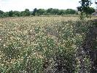 | Acroptilon repens | Russian knapweed
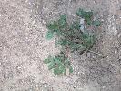 | Amaranthus blitoides | prostrate pigweed
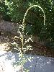 | Amaranthus palmeri | palmer amaranth  carelessweed
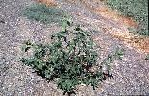 | Amaranthus retroflexus | redroot pigweed
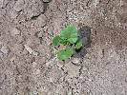 | Anoda cristata | spurred anoda
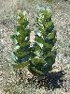 | Asclepias latifolia | broadleaf milkweed
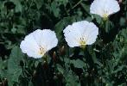 | Convolvulus arvensis | field bindweed
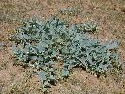 | Cucurbita foetidissima | buffalo gourd
 | Ipomoea cristulata | trans-Pecos morningglory
 | Ipomoea hederacea | ivyleaf morningglory
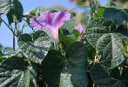 | Ipomoea purpurea | common morningglory
 | Opuntia phaeacantha | plains pricklypear
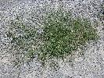 | Polygonum aviculare | yard knotweed  prostrate knotweed
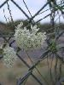 | Sarcostemma cynanchoides | climbing milkweed
 | Toxicodendron rydbergii | poison ivy

Class B Species
Class B Species are limited to portions of the state. In areas with severe infestations, management should be designed to contain the infestation and stop any further spread.

Photo | Scientific Name | Common Name
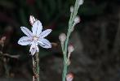 | Asphodelus fistulosus | onionweed
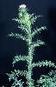 | Carduus acanthoides | spiny thistle  plumeless thistle
 | Centaurea diffusa | diffuse knapweed
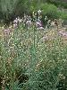 | Centaurea maculosa | spotted knapweed  Centaurea biebersteinii
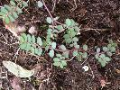 | Euphorbia maculata | spotted spurge  Chamaesyce maculata
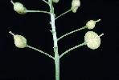 | Lepidium draba | hoary cress  whitetop  Cardaria draba

Class C Species
Class C species are wide-spread in the state. Management decisions for these species should be determined at the local level, based on feasibility of control and level of infestation.
Photo | Scientific Name | Common Name
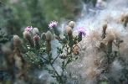 | Cirsium arvense | Canada thistle
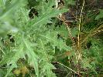 | Cirsium vulgare | bull thistle
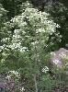 | Conium maculatum | poison hemlock
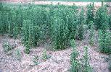 | Conyza canadensis | horseweed  marestail
 | Leucanthemum vulgare | oxeye daisy  Chrysanthemum leucanthemum

APPENDIX E
Useful Websites
Web Links with further information on Forest Stewardship/Management Plan Descriptions, Assistance, and Natural Resource Management.

1) http://www.forestasyst.org/ - This website hosts Forest*A*Syst, a self-assessment guide with the goals of helping new forest landowners articulate their objectives in a written management plan and foster a working relationship with a resource professional who can provide them with technical assistance.

2) http://www.treefarmsystem.org/ - This website provides information on the American Tree Farm System and provides links to the umbrella organization of the tree farm system – the American Forest Foundation, where the “standards of sustainability” are listed for Forest Certification.

3) www.nmforestry.com – This is the website of New Mexico State Forestry. Details the different programs offered and contact information to your nearest District Office.

4) http://www.nm.nrcs.usda.gov/ - This website details the Natural Resource Conservation Service – New Mexico and provides a list of programs, services, and contact information for field offices around the state. The Field Office Technical Guide (http://www.nm.nrcs.usda.gov/technical/fotgintro.html) contains information on cost data (Section I), Forest Management Plan criteria under Conservation Activity Plans (Practice 106 in Section II), and practice standards, specs, and job sheets (Section IV).

5) http://www.bison-m.org/ - this website provides information on wildlife species, habitat, endangered species management and the like. It is a good website to learn about the biology of a particular species.

6) http://www.invasive.org/state.cfm?id=us_nm – this website is a great resource to learn about what invasive weeds are, the management of invasive weeds, considerations, and other organizations and sources of information for management.

7) http://nmrareplants.unm.edu/ - a great website for information on New Mexico rare plant species, biology, and management. This is also a great source for contact information of rare plant experts throughout the state.

8) http://www.firewise.org/ - FIREWISE website, lists the firewise standards adopted by many communities throughout the nation detailing defensible space guidelines to implement around your home and property for protection from wildland fire.

9) http://www.nmenv.state.nm.us/SWQB/ - Water quality information ranging from healthy watersheds to programs available for enhancement of your surface waters. A good source of information about surface water management, programs, and contacts.

10) http://library.duke.edu/research/citing/ – How to cite resources in the bibliography / works cited section of this management plan.
11) http://websoilsurvey.nrcs.usda.gov/app/HomePage.htm - This website is the host of the Web Soil Survey where you can find soils maps and interpretations for the soil resources description required for Section II.
12) http://fws-case-12.nmsu.edu/cwcs/index.php - The electronic version of the Comprehensive Wildlife Conservation Strategy where you can research ecoregions and areas of critical habitat for non-game species.
13) http://www.fs.fed.us/r3/resources/health/field-guide/index.shtml - The electronic version of the Field Guide to Insects and Diseases of Arizona and New Mexico is housed here.
14) http://www.emnrd.state.nm.us/fd/firemgt/cwpps.html - An up-to-date list of Communities at Risk and whether or not they have been addressed in a Community Wildfire Protection Plan can be found at this website.
15) http://www.emnrd.state.nm.us/FD/StatewideAssessment.htm - The New Mexico Statewide Assessment is housed at this website and can be used to assess priority treatment areas on a District and Statewide level.
16) http://weeds.nmsu.edu/ - Our local resource for Class A, B, and C noxious weeds of New Mexico.

