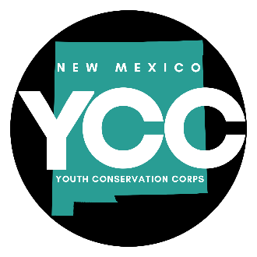
Youth Conservation Corps Fiscal Year 2023 Strategic Plan

Purpose and Statutory Authority

The Youth Conservation Corps (YCC) was established in 1992 to provide a process to employ youth ages 14 - 25 in public projects that conserve New Mexico's natural resources and provide community benefits of lasting value. YCC grants are open to government agencies, tribal governments and 501c non-profits. It is administratively attached to the Energy, Minerals and Natural Resources Department (EMNRD), and pays an annual fee to that Department for administrative, budgetary and IT services. The YCC was created by 9-5B-1-10 NMSA 1978.

Organizational Structure

YCC COMMISSION - Five governor appointees and four state agency designees

Executive Director
Sarah Wood

Budget Analyst / Coordinator
Morgan Tolen

Mission

Promote the education, success and well-being of the youth in our communities and provide community benefits of lasting value through the conservation and enhancement of New Mexico’s natural, cultural and recreational resources.

Guiding Values

Public Service Be responsive, prompt, and courteous to the public and our internal and external partners
Transparency Operate with accountability, clarity, and ethics in a way that builds and sustains trust.
Teamwork Collaborate with each other, the Commission and our partners to achieve success and make continuous improvements.
Best Practices Provide resources to promote best practices for project sponsors to ensure projects are of lasting value.

Benefits to New Mexicans

- Meaningful, community-based employment for young New Mexicans.
- Youth career development, particularly in the natural, cultural, agricultural and recreational sectors.
- Improvements to natural, cultural, recreational and community facilities and resources.
- Tax dollars returned to communities.

FY23 Goals and Strategic Objectives

GOAL 1: Attract a broad variety and geographical diversity of applicants from local governmental units, tribal governments, federal agencies, and non-profits.
OBJECTIVES:
- Develop a consistent social media presence.
- Make in-person visits and presentations to entities who may benefit from a YCC program.
- Reach out to publications who may highlight YCC projects

GOAL 2: Develop and adopt "best practices" guidelines for projects to ensure healthy and resilient natural resources and lasting community benefits.
OBJECTIVES:
- Work with knowledgeable project sponsors, Commission members and other partners to develop 1 - 3 “best practices” requirements for applications.
- Build a library of best practices resources as needed. This may include training resources (online and conferences), research publications, 'how-to' manuals.
- Initiate an annual YCC conference to provide a forum for project sponsors to share processes and receive training.

GOAL 3: Encourage further education and build a clear pathway from YCC service to New Mexico careers.
OBJECTIVES
- Ensure 85% of all corps members eligible for full benefits receive them.
- Work with New Mexico agencies, such as State Parks, Forestry and the State Land Office to add YCC service as a job application preference.
- Cross-post job openings from related agencies, non-profits and businesses on YCC website and social media.
- Support and contribute to youth mentoring program in collaboration with other state agencies and endeavOR.

GOAL 4: Foster work ethics, stewardship and communal heritage in young New Mexicans.
OBJECTIVES
- Develop an updatable multi-media NMYCC orientation training that covers our mission, core values, history, benefits and further education and career resources.

Performance Measures FY23:

Percentage of all grant award monies used for corps member wages
Target: 70%

Number of youth employed annually
Target: 840

Percent of corps members eligible for full benefits receiving those benefits
Target: 85%

