
State of New Mexico
Energy, Minerals and Natural Resources Department

Michelle Lujan Grisham, Governor
Sarah Cottrell Propst, Cabinet Secretary Todd E. Leahy, JD, PhD, Deputy Cabinet Secretary Toby Velasquez, State Parks Division Director

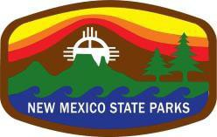
FOR IMMEDIATE RELEASE:

Contact: Toby Velasquez, Director
State Parks Division, EMNRD
505-490-0891
toby.velasquez@state.nm.us

June 24, 2022

Four State Parks to re-open after temporary closures due to
extreme fire conditions and national forest closures

Santa Fe, NM – The Energy, Minerals and Natural Resources Department (EMNRD) State Parks Division announces that Cimarron Canyon, Fenton Lake, Hyde Memorial, and Manzano Mountains State Parks will re-open to the public for day-use on Friday, June 24th and for camping Monday, June 27th.

Two State Parks – Morphy Lake, Pecos Canyon – will remain closed at this time due to impacts from the Calf Canyon/Hermits Peak Fire. All New Mexico State Parks have implemented the EMNRD State Forester Fire Restriction Order 2022-02, which prohibits smoking, fireworks, campfires, open burning, and open fires on all non-municipal, nonfederal, and non-tribal lands statewide.

It is important for visitors to continue to check for details on specific park hours of operation and additional information before visiting any New Mexico State Park. Check the State Parks website and know before you go!

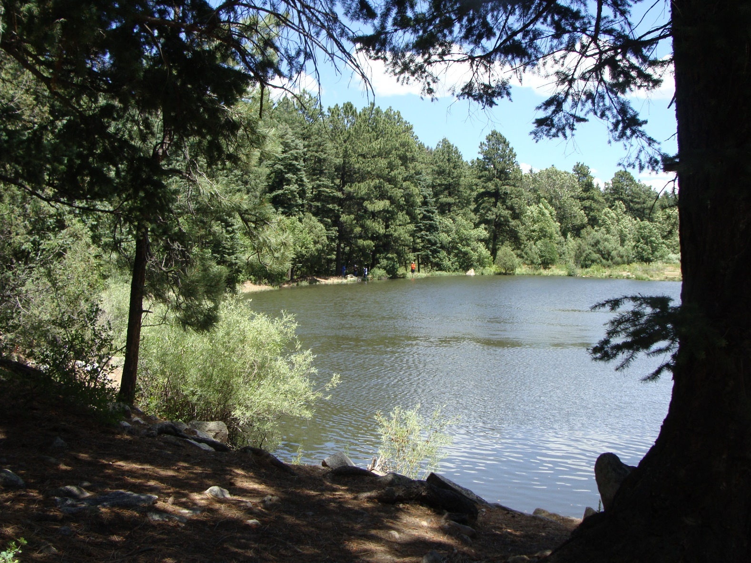

State Parks are ideal for fishing, camping, hiking, and wildlife viewing. Photo: NM State Parks

###
The Energy, Minerals and Natural Resources Department provides resource protection and renewable energy resource development services to the public and other state agencies.
https://www.emnrd.nm.gov

