New Mexico
Youth Conservation Corps

Calendar Year 2022
Administrative Manual

811 St. Michaels Drive Ste 206
Santa Fe, NM 87505

Phone: 505-470-3710
Fax: 505-988-7313
https://www.emnrd.nm.gov/about-ycc/

Table of Contents
OUR MISSION 3
IMPORTANT THINGS TO KNOW 4
MODIFICATIONS TO THE PROJECT 4
How to request a change: 5
PROJECT TRACKING 5
CORPS MEMBERS - Managing 5
CORPS MEMBERS - Documentation 5
CORPS MEMBERS - Entering in the Project Sponsor database 6
REQUESTS FOR REIMBURSEMENT 12
Organization of the Reimbursement Packet 14
Entering a Status Report: 16
JUNE 30 - FISCAL YEAR END REIMBURSEMENT PACKET 19
PROJECT COMPLETION 21
Corps Member Online Survey 22
Releasing the Corps Members 24
Accessing the Final Report 27
SITE INSPECTION and FILE AUDIT 29
CORPS MEMBER BENEFITS 30
Cash reimbursement 30
Educational tuition voucher 30
APPENDIX A: New Mexico Proof of Residency Documents 31
APPENDIX B: Child Labor Laws in New Mexico 32
APPENDIX C: Examples of Forms 37

OUR MISSION
The mission of our office is to manage the YCC program. That's it. We are not too busy to answer your questions, walk you through a form or process, or hash out a solution to an unexpected problem.
That is what we are paid to do.

If you have a question about your contract or project, CALL or E-MAIL THE YCC. We want your project to succeed.

Sarah Wood - 505.470.3710 (this is a mobile number) sarah.wood@state.nm.us

IMPORTANT THINGS TO KNOW

Letter to Proceed date: You may start incurring approved project expenses as soon as you receive the "Letter to Proceed" from the YCC. Invoices or expenses incurred before the date on this letter will not be reimbursed.

Project Length: The project starts when the first corps member is hired and ends when the last corps member is released. The project may not exceed 26 weeks in length. Splitting a project into two time segments requires written approval from the YCC, unless it is already in your proposal.

Before you start the project: Non-profits and tribes must provide the YCC office a Certificate of Insurance documenting that workers compensation and general liability policies are in place for the duration of the project. YCC does NOT need to be named as additional insured on these policies. If insurance expires mid-contract, the sponsor must send an updated certificate to the YCC.

Contract termination date: All the contracts (Service Agreements) have the same expiration date of March 28, 2023. This gives you some flexibility to adjust your project dates. However, it does not mean you may extend your project beyond 26 weeks.

MODIFICATIONS TO THE PROJECT
(This is from Paragraph 4 of the contract)

YCCC may authorize non-substantive changes, as defined below, to the project without requiring an Amendment to this Agreement. You must submit a request for such changes, in writing, with a justification, to the YCCC for approval, which shall also be in writing.
Non-substantive changes may include:
- transfer of funds from one-line item to another (except transfers from the wages line item)
- replacing a work project from the Project Objectives with an alternative but effectively similar project due to unforeseen circumstances or a beneficial opportunity
- changing a work site due to unforeseen circumstances
- changes in the amounts or nature of materials and supplies purchased or contributed (as long as they are relevant to the project)
- changes in the training curriculum due to unforeseen circumstances
- changes in Contractor contribution amounts

Substantive changes that shall require an amendment to this Agreement include:
- decreases in the portion of the project’s budget designated as wages for YCCC members that drop below 70% of funds requested.
- changes in the essential nature of the Project Objectives.

How to request a change:
Send an email to sarah.wood@state.nm.us with details of the change and a justification for the change. Generally, you will receive a reply within 24 hours of the request. We also encourage you to call the YCC at 505.470.3710 to discuss changes before writing to us.

PROJECT TRACKING
YCC has entered your project specifics into our database. YCC expects project sponsors to enter corps members' data, status reports and the final report using YCC's internal database: https://wwwapps.emnrd.nm.gov/YCC/YCCPTS/Sponsor/Login.aspx

If you don't remember your username or password, or don't have one, e-mail sarah.wood@state.nm.us to get one.

CORPS MEMBERS - Managing
Sponsors shall verify corps members meet the following eligibility requirements at the time of hire.

- Corps members shall be between the ages of 14 – 25 at the time of hire.
- New Mexico residency. See Appendix A for acceptable proofs of residency.
- Unemployed at the time of hire. There is no minimum time someone must be unemployed; a corps member may leave a job on a Friday and be hired with the YCC on Saturday.
- Corps members may not be the child or sibling of the hiring officer or project supervisor.
- Have a work permit if under the age of 16. Work permits may be obtained from the Department of Workforce Solutions: https://www.dws.state.nm.us/Child-Labor
- May be in-school or out-of-school youth; however, there are restrictions in the number of hours in-school youth under the age of 16 can work (see Appendix B)

Sponsors shall enforce all labor laws and shall be familiar with child labor laws as they apply to employees under the age of 18. See Appendix B for New Mexico's child labor law. Corps members shall be compensated, at a minimum, as provided by law following the state or municipality established minimum wage. Project sponsors may request wage increases of no more than ten percent of starting wage for corps members based on promotion, performance, or additional responsibilities; and as budget allows. If your personnel policy includes holiday or sick pay, YCC will support that policy. Under no circumstances will the commission reimburse project sponsors for overtime or hazard pay. Project sponsors shall follow their established personnel policies for dismissal of corps members. Sponsors are encouraged to provide opportunities for improvement prior to dismissal.

CORPS MEMBERS - Documentation
Keep on File for the YCC Audit:
- The YCC Certificate of Eligibility (generated when corps members are entered in our database, see next section on how to do that)
- Work permit if under the age of 16.
- W-4 for the current year (https://www.irs.gov/pub/irs-pdf/fw4.pdf )
- I-9, Employment Eligibility Verification (https://www.uscis.gov/i-9). Please ensure this is filled out correctly.
- Proof of New Mexico Residency - See Appendix A for full list of acceptable proof. Passports, baptismal certificates, or birth certificates are not proof of residency.
- Proof of Age (14 to 25) – Driver's license; New Mexico ID; birth certificate; school record.

CORPS MEMBERS - Entering in the Project Sponsor database
Corps members must be entered into the database before YCC will reimburse their wages. The YCC requires that some corps member identifying information is entered in our database to confirm eligibility as a corps member, track the number of weeks worked on YCC projects, and contact the corps member to award benefits.

Below is a walk-through of the on-line Project Tracking app that shows you how to enter corps members.

1. Log in at https://wwwapps.emnrd.state.nm.us/YCC/YCCPTS/Sponsor/Login.aspx
OR access the link from the YCC's public web page at https://www.emnrd.nm.gov/about-ycc/ycc-project-sponsors/

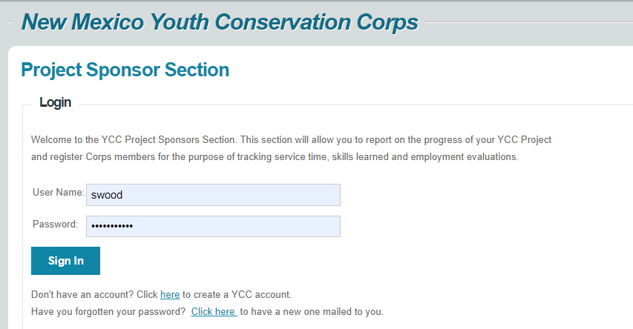

Scroll down to the Projects section and click on your current project. If you've had several YCC projects, your current project will be listed last. If you can't see your projects, contact YCC and we'll sort it out.

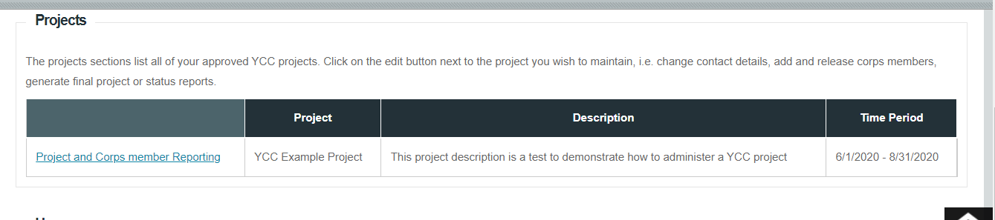
Scroll down to the Corps Member Positions section.

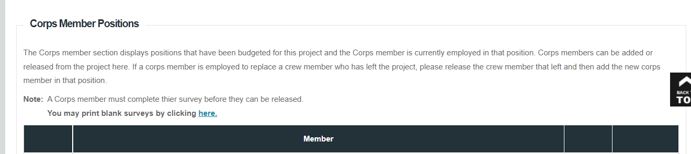

Click on the "Add Corps Member" link.
On the next screen enter the corps member's first and last name and press the ADD button.
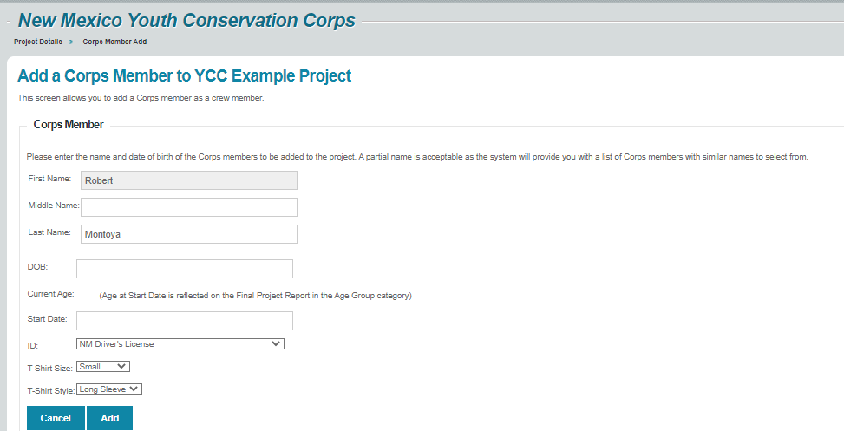

If the corps member has the same name as a corps member in the system, a screen will pop up with the title Existing Corps Member. If the information on this screen matches your corps member's information, press Add and the corps member will be added to your project.

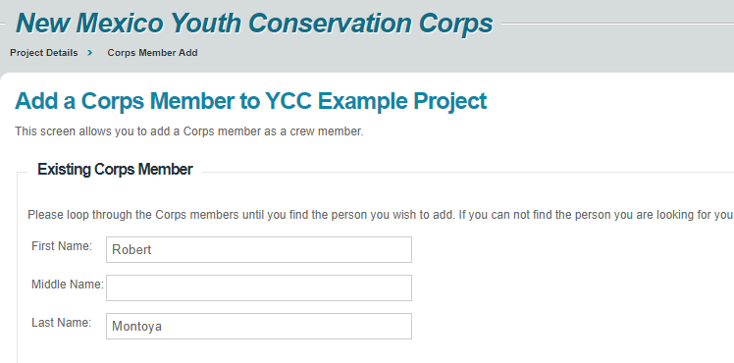
If this person is not your corps member, click the Next button until you find the correct information

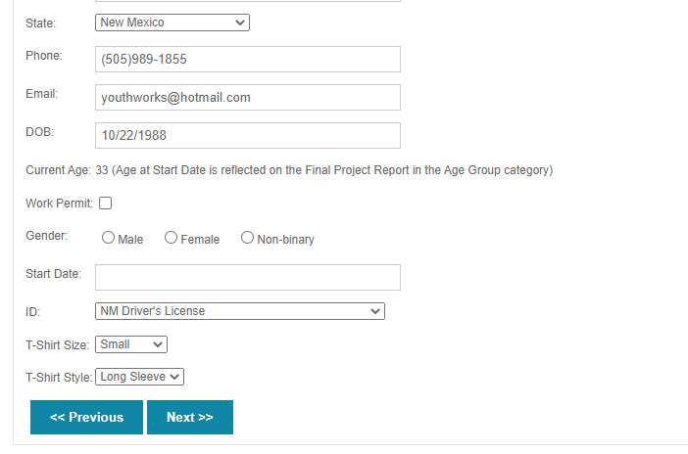

OR reach a screen called New Corps Member. Here, enter the corps member's address, phone, e-mail etc. Then press Add and the corps member will be added to your project.

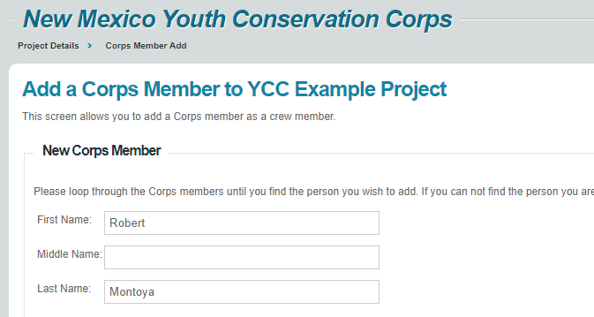

On the next screen, select the "Certificate of Eligibility" option.

Print the Certificate of Eligibility or save it electronically as a PDF and keep with the employee's file. The corps member's project key printed at the bottom of the page is the corps member's login for their survey at the end of the project.

Press the blue Return link at the top right.

This will take you back to the screen below; press "Project Details" to add another corps member.

You may also print the Certificate of Eligibility from the list of corps members. Please also assign a 'Leader', 'Trainer' or 'Member' role to the corps member.

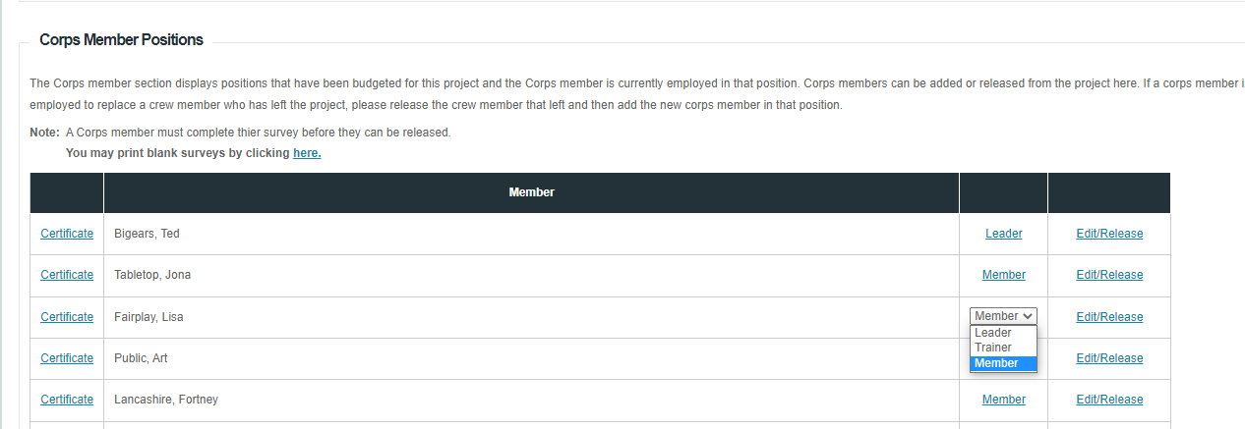

REQUESTS FOR REIMBURSEMENT
Project Sponsors must use their own funds to pay for expenses, following the approved costs in the cost proposal, and submit a request for reimbursement to the YCC office. YCC provides forms to help with this.

Reimbursement Forms
The Invoice for Reimbursement workbook has your project budget pre-loaded, and the cost response forms for reference. This invoice must be filled in and submitted to receive your reimbursement. All costs you enter in this form must be backed up with documentation. The invoice automatically tracks your budget, contribution and number of weeks worked with every invoice.

Cells highlighted in yellow are where you'll enter information.

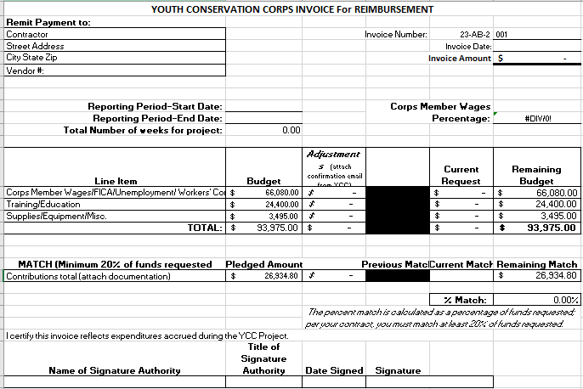

Reimbursement Worksheets: These worksheets have formulas which total items up automatically and reduce errors that cause reimbursement delays. The worksheets are optional, and you may use your own system, but please include summary spreadsheets of some kind.
- Corps Member Wages; Training & Education; and Supplies, Equipment and Miscellaneous. These correspond to the line items on the Invoice.
- Vehicle usage form. Use this form if you have requested mileage reimbursement in your approved proposal. If you have requested to be reimbursed for fuel purchases, do not use this form.
- Offeror contribution documentation. This worksheet should be used to itemize and index your in-kind contributions.

When submitting a reimbursement, please use paper clips to attach documents, not staples. Tape smaller invoices to an 8 ½” x 11” sheet of paper.

Organization of the Reimbursement Packet
There are 6 parts to a reimbursement packet: the Invoice; Corps member wages; Training & education; Materials, supplies & equipment; Offeror contribution; a Status report; and Photos.

Section 1: The Invoice. Fill this in with the totals for Corps wages, Training, Supplies and Match (offeror contribution).

Section 2. Wages/FICA/Unemployment/Workers' Comp (Worksheet: Wages)
Include the following supporting documentation. Please arrange paystubs in alphabetical order.
- Copies of Corps members’ cancelled checks or pay stubs OR the direct deposit print-out attached to the timesheet.
- The Wages worksheet (see Appendix C for example) that summarize the payroll for the reimbursement period OR your payroll register that summarizes the payroll.

Corps member wages are equal to gross pay + FICA + Unemployment +Workers Comp. These numbers may be found in your approved cost proposal.

Enter the total in the first line of Current request in the invoice.

YCC is no longer requiring timesheets for corps members.

Section 3. Training and Education (Worksheets: Training/Education)
Enter the class, session, trainer wages or training expenses etc. into the Training/Education worksheet (see Appendix C for example) or similar. For each item include the following supporting documentation:
Invoices or receipts for each item.
- Legible, clearly dated and with the business name and address printed on them.
- Descriptions and quantities of each item
- Taped to a sheet of 8 1/2" x 11" paper if invoices are small. More than one receipt may be taped to one piece of paper.
- Time sheets for each trainer, if claiming trainer time.
Proof of payment for each item which may include
- purchase order (for government entities)
- copy of a payment voucher (for government entities)
- copy of a cancelled check or check register or credit card statement (non-profits)
- Copies of trainers' checks or pay stubs OR the direct deposit print-out if claiming trainer time.

Enter the total in the second line of Current request in the invoice.

Section 4. Supplies, Equipment and Miscellaneous (Worksheets: Supplies, Eqpt, Misc. and Vehicle Usage)
Use the Supplies, Eqpt, Misc. worksheet (see Appendix C for example), or similar worksheet to itemize purchases and admin costs you spent in accordance with your approved proposal. Include the following supporting documentation:
Invoices or receipts for each item.
- Legible, clearly dated and with the business name and address printed on them.
- Descriptions and quantities of each item
- Taped to a sheet of 8 1/2" x 11" paper if invoices are small. More than one receipt may be taped to one piece of paper.
- Time sheets for each trainer, if claiming trainer time.
Proof of payment for each item which may include
- purchase order (for government entities)
- copy of a payment voucher (for government entities)
- copy of a cancelled check or check register or credit card statement (non-profits)
- if claiming an overhead percentage, please include calculations that are consistent with your approved proposal.

Vehicle Usage Form for Mileage Reimbursement (See Appendix C for example)

This is a supplementary form if you have requested mileage reimbursement in your proposal. You may not request reimbursement for both gas and mileage for the same vehicle. Add the totals from the Vehicle Usage form to the Supplies, Equipment and Materials line item.

If the vehicle is private, the form must be signed and dated by the driver (Payee) and the Supervisor. The Project Sponsor reimburses the driver for the mileage and submits the form along with proof of payment. Print copies of this form so drivers can mark down the trips as they occur.

If you are using a company vehicle, there is no need to include proof of payment, but the form must be submitted.

Section 5. Offeror Contributions
Use the Offeror Contribution worksheet (see Appendix C for example) to enter your contributions. Then enter that number under "Current Match" on the invoice. You must submit supporting documentation for at least 20% your contributions. See Sections 2-3 above for what supporting documentation is needed.

Section 6. Project Status Report
A Project Status Report must accompany every reimbursement. The Report is found on the Project Sponsor site:

Entering a Status Report:

Log in on https://wwwapps.emnrd.nm.gov/YCC/YCCPTS/Sponsor/Login.aspx Scroll down to the "Projects" section and select the current project.

Scroll down to the "Projects Status Reports" section and click Add Status Report

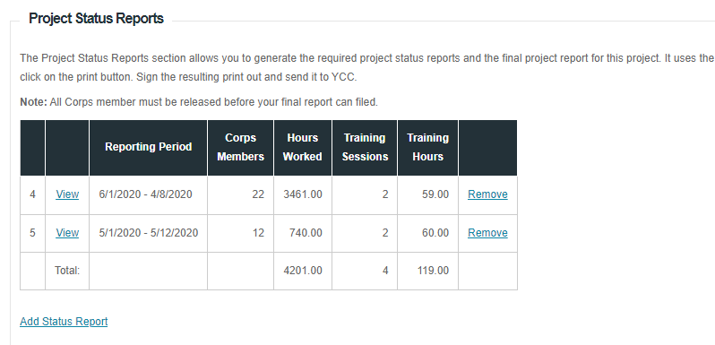

The Report Details section asks for the start and end date of the report, and the name and title of the person submitting the report.

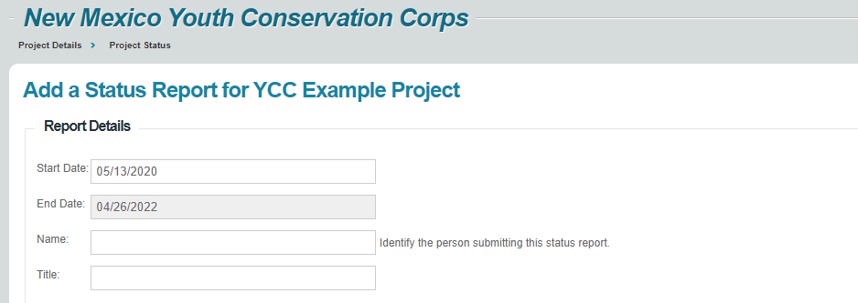

The Project Work Plan section asks for a short narrative on work project process, accomplishments, and issues. Enter the number of corps members working for the status report period, and the total number of hours paid. If 10 corps members worked 160 hours, enter 10x160=1600 hours.
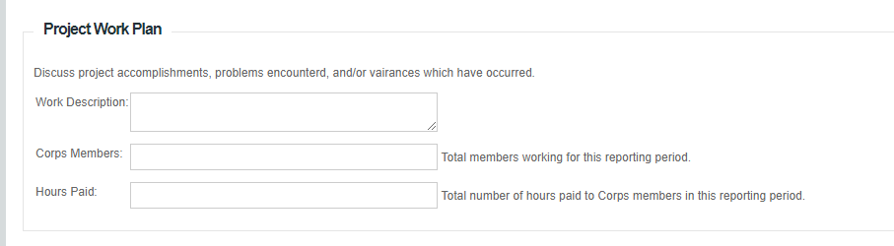
The Education section asks for a narrative on training activities, the number of training sessions and the total number of training hours. The green box has examples of how to add up the total training hours.
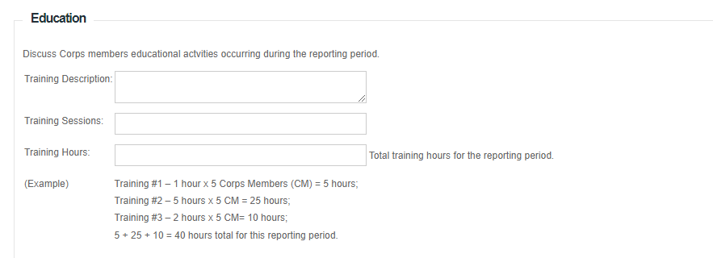

The final Open Items section has space for anything else you would like to add. Then scroll to the bottom and press the blue Submit/Print button:
You will be able to print the report, sign it, and include it with your reimbursement packet:

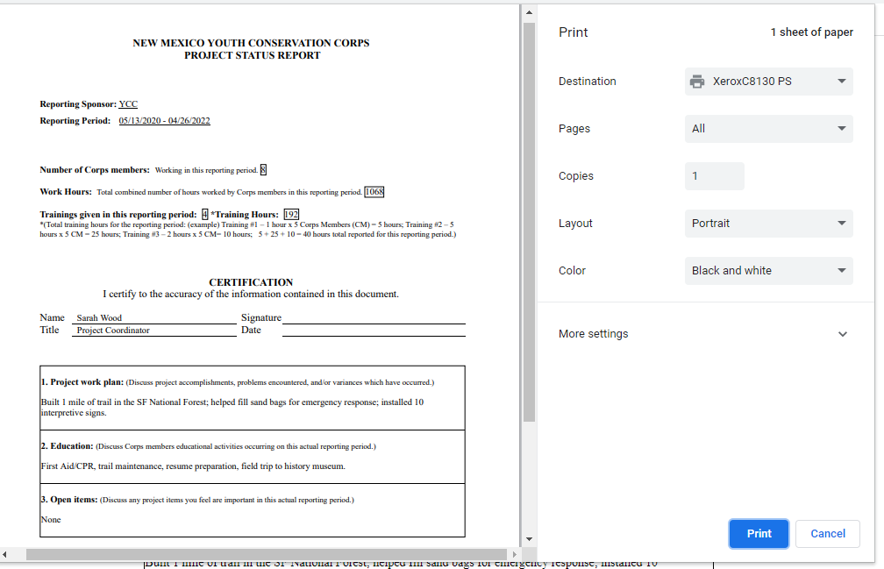

After you print the report, press "Return" in the upper right-hand corner of the screen to return to the Project Details page.

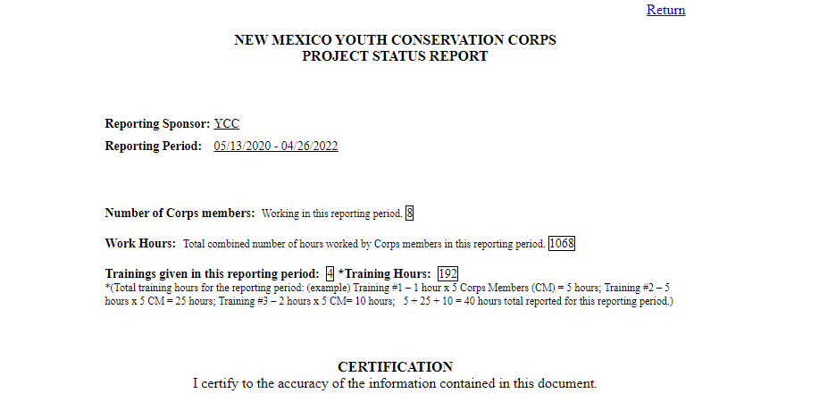

Section 7. Photos. The YCC requires at least two photos of the project with each reimbursement. Please e-mail to sarah.wood@state.nm.us or provide a link. Before and after photos, pictures of corps members working or training, etcetera.

Reimbursement packets must be printed out and mailed to the YCC office at

811 St. Michael's Drive
Suite 206,
Santa Fe, NM 87505

Except for the June 30, reimbursement there are no deadlines, however, please submit reimbursements about once every four weeks.

JUNE 30 - FISCAL YEAR END REIMBURSEMENT PACKET

The State of New Mexico's fiscal year (FY) ends each year on June 30.

All Project Sponsors should plan a reimbursement packet that includes all expenses up to and including June 30. The reimbursement packet needs to arrive at the YCC office by JULY 15.

To be reimbursed for wages in June, the Project Sponsor MUST submit timesheets and payroll expenses for June by July 15. If a pay period straddles June 30, submit timesheets and wage calculations for days worked up to June 30, even though you may not have paid the Corps member for those days of work. Proof of payment may be included with the next reimbursement.

If requisitions or purchase orders for services and supplies are created before June 30, these services and supplies must be delivered, invoiced, and paid for before June 30. The invoices must be included with the FY End reimbursement. YCC will not accept invoices dated before or on June 30 past the July 15 deadline.

PROJECT COMPLETION

The YCC project ends when the last corps member is released from employment. Please notify the YCC when you have released the last corps member.

There are four steps to completing the project.
- Corps members must complete the online skills survey. Make completing the survey part of every corps member's last day.
- Project sponsor releases the Corps member in the Project Sponsor section.
- Project sponsor is then able to access the Final Project Report in the Project Sponsor section.
- The Project Sponsor prepares and submits the final reimbursement packet within 45 days after completion of the Project. This packet is prepared in the same manner as the previous reimbursement packets except that both a Status Report and a Final Project Report is submitted.

Corps Member Online Survey

Each Corps member is assigned a project key that enables them to access the survey. The project key is printed at the bottom of the Certificate of Eligibility Form.

You can print out the survey (see screenshot below) from the Corps Member positions section of the project sponsor portal, and have the corps members complete it by hand, but data will need to be entered for each corps member using their project key.

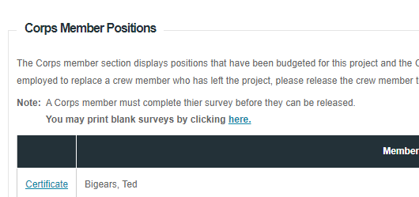

To complete the survey online, Corps members should go to https://www.emnrd.nm.gov/about-ycc/for-ycc-corps-members/ and click on online survey:

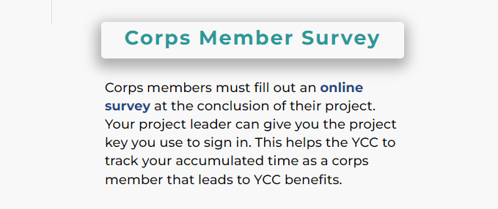

The log-in page asks the corps member to enter their Project Key, which is printed at the bottom of the Certificate of Eligibility.

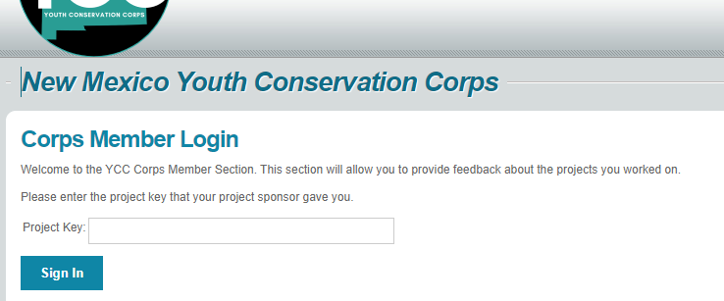The corps member completes the survey and presses Submit/Print Survey. The screenshots below show the beginning and the end of the survey.

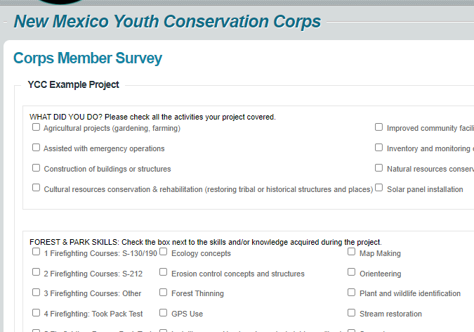

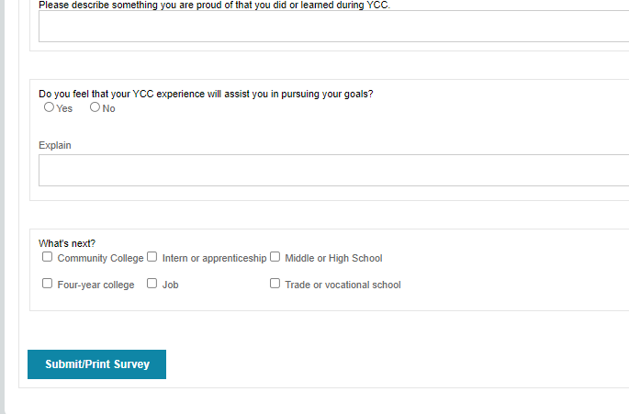

Releasing the Corps Members
You will be able to release corps members after they have completed the survey.

Log onto the Project Reporting Site from https://wwwapps.emnrd.nm.gov/YCC/YCCPTS/Sponsor/Login.aspx

Scroll down to the "Projects" section and select the current project.

Scroll down the Corps Member section; select the Edit/Release option:
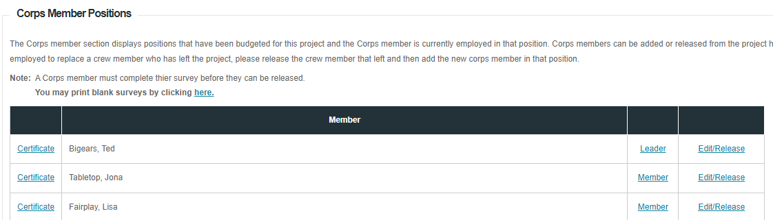

You will then see a screen like this. Scroll down.

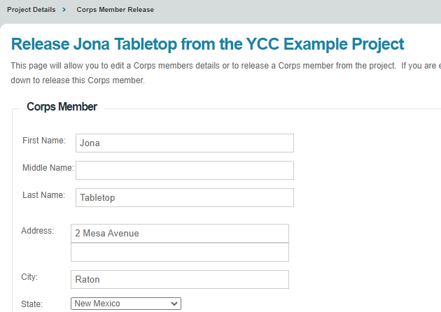

Complete each section to release the corps member:
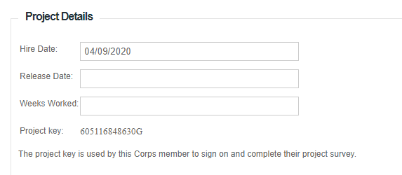
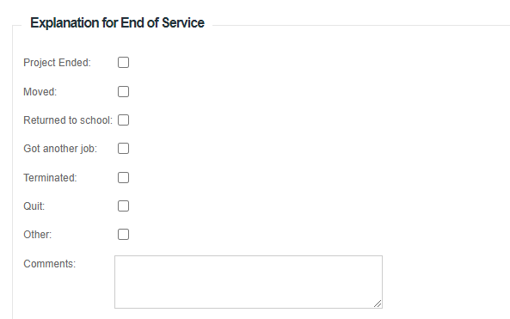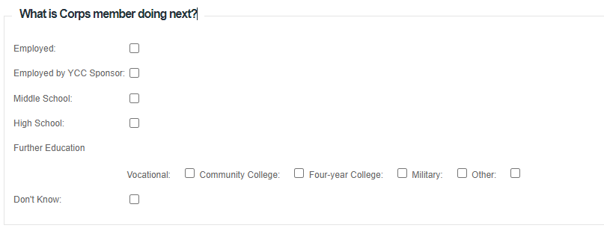

The final section is the evaluation; if you give a corps member an Unsatisfactory evaluation, their time will not count towards YCC service for corps members benefits.
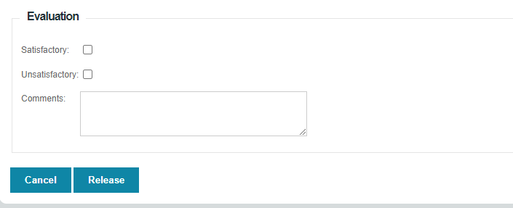
If you try to release a corps member before they have done their survey, you will get an error. Press cancel and have the corps member do the survey or call the YCC if a member cannot complete the survey.

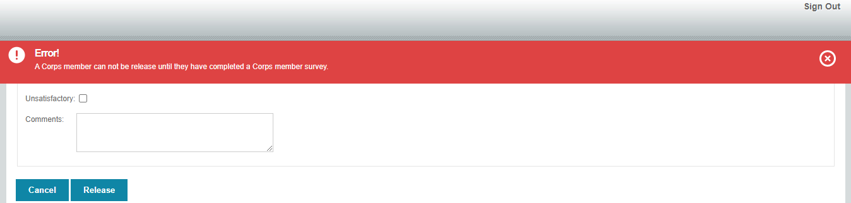

Accessing the Final Report
After all corps members are released, complete a Status Report and a Final Report

The Final Report link will appear at the bottom of the Project Details page when you log into https://wwwapps.emnrd.nm.gov/YCC/YCCPTS/Sponsor/Login.aspx

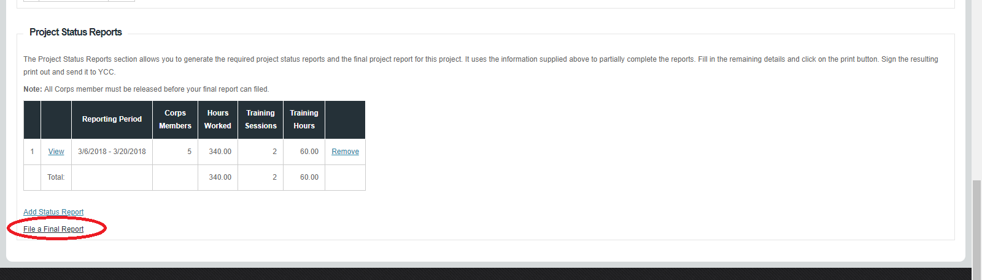
Many fields of the Final Report will automatically be filled in. You will be asked to do a final summary. 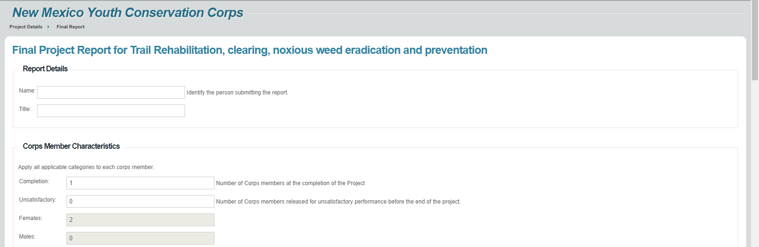

Print, sign and submit with the Final Reimbursement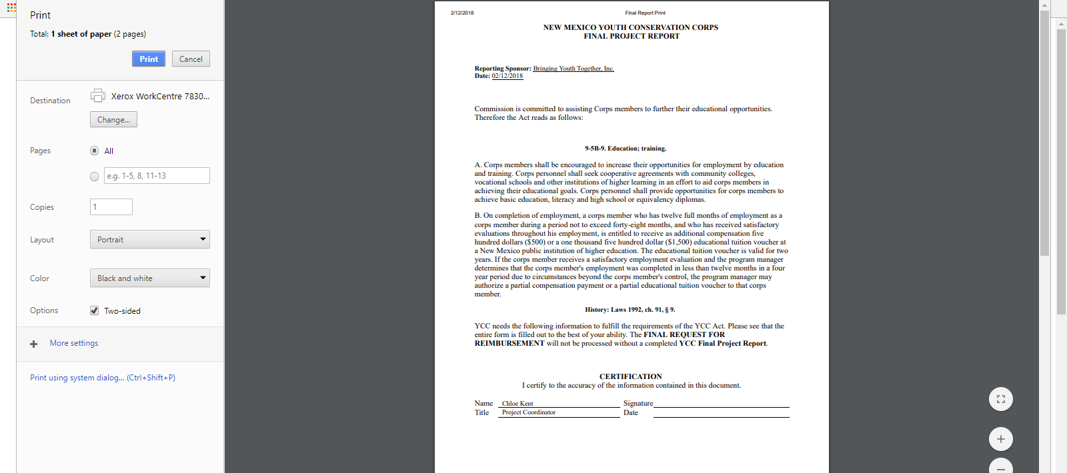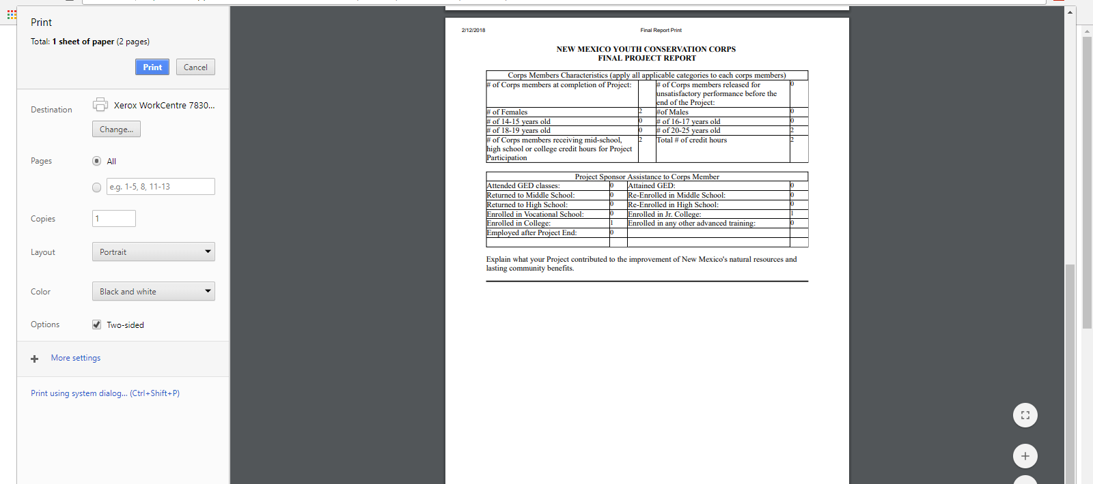

SITE INSPECTION and FILE AUDIT

YCC will perform a site inspection and file audit. This consists of visiting work project locations and reviewing project files. YCC will notify the Project Sponsor prior to the visit to set up times and locations.

Project Sponsors should keep the following information in a YCC project file:
- YCC job announcements and advertisements
- Corps member applications and resumes
- Interview Information and selection criteria
- YCC Contract & Correspondence
- Reimbursement documents.
- Contribution documents.
- Personnel Files
  - YCC Certificate of Eligibility
  - I-9
  - W-4
  - Proof of New Mexico Residency
  - Proof of age
  - Work permit if corps member is age 14 or 15.

YCC staff may also conduct visits during a project.

CORPS MEMBER BENEFITS
The Youth Conservation Corps (YCC) Commission offers a $1,500 educational tuition voucher OR a $500 cash compensation to YCC corps members who have worked on a YCC project for 12 months (48 weeks) within a 48-month period (4 years). The YCC Commission may offer a prorated amount based on a minimum of 32 weeks worked.
The YCC will contact corps members and their project sponsors at the conclusion of every project to inform them of their eligibility and provide the necessary information.

Cash reimbursement
Corps members who opt to receive the cash compensation will receive one lump-sum payment.

Educational tuition voucher
The educational voucher is good for reimbursement of expenses at a New Mexico institution of higher education, including on-line education, associated with an accredited New Mexico institution of higher education or vocational training. The voucher is valid for two years and expenses will be reimbursed upon when valid receipts are sent to us.

Expenses the YCC will reimburse include: tuition, fees, software, textbooks, calculators, lab supplies and classroom supplies such as paper, toner cartridges, and other similar items.

Expenses the YCC will NOT reimburse include: personal expenses, transportation, computers, residential rent, and food.

APPENDIX A: New Mexico Proof of Residency Documents
Page of

(Click to go back to corps members section)
Reference: 18.19.5.16 New Mexico Administrative Code

Please note passports, birth certificates and baptism certificates are not proof of New Mexico residency.

- A valid New Mexico driver's license
- A valid New Mexico ID card or
- A current real property rental agreement or purchase agreement
- A utility bill dated within 60 days, such as water, gas, electric, waste, telephone, cable, or satellite bill, but not a bill for a cell phone
- An insurance bill, card, or binder, dated within the past 6 months
- A bank or credit card statement dated within 60 days that contains the corps member’s name and address
- An employment pay stub, dated within 60 days that contains the corps member’s name and address
- A current, local property tax statement or mortgage documents
- A document from an education institution, such as a transcript, report card or enrollment confirmation, that contains the corps member’s name and address and is dated within 60 days
- Original documents from a city, county, state, tribal or federal government organization attesting to the fact that the corps member is a New Mexico resident
- A New Mexico medical assistance card with address on card, letter from issuing agency that came with card showing name and address, or profile printout from issuing agency
- A New Mexico public assistance card with address on card, letter from issuing agency that came with card showing name and address, or profile printout from issuing agency
- Documents acceptable for corps members less than 18 years of age:
- Documents indicating membership in a New Mexico religious organization
- Documents indicating membership in a New Mexico sports organization,
- Two proofs of New Mexico residency of the parent/guardian and an affidavit from the corps member’s parent or guardian stating that the corps member lives with that person
- A New Mexico medical or public assistance card, profile printout or a letter from the issuing agency
- A document evidencing eligibility and proof that the corps member's parent or guardian is currently receiving services from a non-profit organization qualified pursuant to Section 501(c)(3) of the Federal Internal Revenue Code of 1986 provided the document displays the corps member’s address.

APPENDIX B: Child Labor Laws in New Mexico

(Click here to go back to corps members section)
ARTICLE 6
Employment of Children

50-6-1. Children under fourteen; employment prohibited.
No child under fourteen years of age shall be employed or permitted to labor at any gainful occupation unless otherwise provided for in the Child Labor Act [Chapter 50, Article 6 NMSA 1978].

0-6-1.1. Short title.
Chapter 50, Article 6 NMSA 1978 may be cited as the "Child Labor Act".

50-6-2. Work permit for children fourteen to sixteen.
A child over the age of fourteen years and under the age of sixteen years shall not be employed or permitted to labor at any gainful occupation without procuring and filing a work permit unless otherwise provided for in the Child Labor Act.

50-6-3. Maximum hours for children fourteen to sixteen.
A. Children over the age of fourteen and under the age of sixteen years shall not be employed or permitted to labor at any gainful occupation for more than forty hours in any one week nor more than eight hours in any one day when school is not in session unless otherwise provided for in the Child Labor Act.
B. Children over the age of fourteen or under the age of sixteen shall not be employed unless otherwise provided for in the Child Labor Act:
(1) before 7:00 a.m. or after 7:00 p.m. during the calendar school year;
(2) before 7:00 a.m. or after 9:00 p.m. outside of the calendar school year;
(3) during school hours, except as provided for in work experience and career exploration programs;
(4) more than three hours per day during school days; or
(5) more than eighteen hours per week during school weeks.

50-6-4. Prohibited occupations for children under sixteen; exceptions.

A. A child under the age of sixteen years shall not be employed or permitted to labor at any of the following occupations or in any of the following positions:
(1) on or around belted machines while in motion;
(2) on or around power-driven woodworking machines used for cutting, shaping, forming, surfacing, nailing, stapling, wire stitching, fastening or otherwise assembling, processing or printing wood or veneer;
(3) on or around power-driven hoisting apparatus with the exception that this section shall not prohibit the operation of an automatic elevator that is controlled by pushbuttons making leveling, holding, opening and closing of the car and hoistway doors entirely automatic;
(4) in or about plants, establishments or jobs using, manufacturing or storing explosives or articles containing explosive components;
(5) electronics jobs where the child is exposed to electrical hazards;
(6) in or about any establishment where malt or alcoholic beverages are manufactured, packed, wrapped or bottled;
(7) municipal firefighting whether using volunteers or paid employees;
(8) manufacture of goods for immoral purposes;
(9) in any employment dangerous to lives and limbs or injurious to the health or morals of children under the age of sixteen years; or
(10) soliciting door-to-door for other than a nonprofit organization or in other activities approved by the parent or guardian.
B. The provisions of this section do not apply to:
(1) children engaged in working with equipment in any school or place where cooperative education or science is taught while under supervision of an instructor;
(2) apprentices while under the supervision of a journeyman in a certified apprenticeship program; or
(3) children employed in a film or television production, where the set may be considered physically hazardous or special effects are used; provided that a New Mexico-certified trainer or technician accredited in a United States department of labor occupational safety and health administration-certified safety program specific to the film or television industry is present at all times that the child is exposed to the potentially hazardous condition.
C. Additional hazardous occupations not specifically listed in this section shall be determined by the state child labor inspector following consultation with the employer who wishes to employ minors over the age of fourteen years and under sixteen years of age.

50-6-5. Prohibited occupations for children under eighteen.
No child under the age of eighteen years shall be employed or permitted to labor in any mine or quarry underground or at or about any place where explosives are used. However, children under the age of eighteen years but not under the age of fourteen years may be employed to separate mica if blasting is done during periods when there is nobody working, and the mica is subsequently removed from the blasting area to another site for operation.

50-6-7. Work permit; issuance; authorized officials; application; contents; proof; copies; maximum term.
A. Work permits shall be issued only by the school superintendents, school principals, designated issuing school officers or the director of the labor and industrial division of the labor department or the director's designee.
B. A work permit shall not be issued to a child until satisfactory proof has been furnished that the work in which the child is to engage is not dangerous to the child or injurious to the child's health or morals.
C. The application for the work permit shall show that the work to be performed would not result in injury to the health, morals or mental development of the child. Satisfactory proof of the age of the child at the date of the application shall be furnished. Any application for the employment of children at any gainful occupation during the session hours of the school of the district in which the child resides shall set forth, in addition to the foregoing, the necessity to the family or the dependents of the child or for the child's own support of the income to be derived from the employment or labor.
D. Whenever the person authorized to issue the work permit is satisfied that the provisions of this section have been complied with, the person shall issue to the child a work permit, keeping one copy on file and sending one copy of the permit to the labor and industrial division of the labor department.
E. No work permit shall be in force without renewal for a longer period than one year from the date of issuance.

50-6-8. Renewal of work permits.
The officer authorized to issue work permits may renew a work permit at the expiration date thereof for a period not exceeding one year upon a satisfactory showing upon the part of the child, the child's parent, guardian or custodian that the provisions of the Child Labor Act are being complied with and that the child is in good health. The extension of time shall be made by the officer writing upon the certificate the following words: "this work permit is extended for a period of ...... days from this date" and by the officer signing the certificate.

50-6-9. Employer's records; form of permits.
Whenever any child is employed or permitted to labor at any gainful occupation permitted by the laws of this state, the employer of the child shall preserve on file the work permit of the child and shall keep posted in a conspicuous place about the premises where the child is employed a list of all children there at work by virtue of work permits. The form for all work permits shall be prepared by and shall contain such information concerning the identity of the child as may be prescribed by the labor and industrial division of the labor department.

50-6-10. Inspection of work permits, records and premises by the labor and industrial division of the labor department.
All work permits and records and the premises where children are employed are subject to inspection by representatives of the labor and industrial division of the labor department. The director of the division may, for cause, cancel a work permit with the concurrence of the officer issuing the permit but, in case they disagree, the district court may cancel the permit on complaint setting forth the grounds therefor under the provisions of the Child Labor Act.

50-6-11. [Habitual presence of child under sixteen at a place of work during school hours; prima facie evidence of employment.]
The frequent presence of any child under sixteen years of age, during school hours, at any place where workers are at work more or less habitually shall be prima facie evidence that such child is unlawfully engaged in labor, if no permit is exhibited.

50-6-12. Penalties.
A. A person who employs a child, or who is the parent, guardian or custodian of a child, and who permits that child to be employed in violation of any of the provisions of the Child Labor Act is guilty of a petty misdemeanor. Each violation of the Child Labor Act constitutes a separate offense. A second or subsequent conviction of an employer, parent, guardian or custodian for violation of the Child Labor Act is a misdemeanor.
B. The director of the labor and industrial division of the labor department may report a violation of the Child Labor Act to the local district attorney, who may prosecute the alleged violator.

50-6-13. District court jurisdiction.
The district courts are hereby given original jurisdiction in all cases of violations of the provisions of the Child Labor Act.

APPENDIX C: Examples of Reimbursement Forms
(Click here to go back)

