

New Mexico
Youth Conservation Corps

Calendar Year 2025
Administrative Manual

New Mexico Youth Conservation Corps Commission
1220 South St. Francis Drive (click for detailed directions to the office)
Santa Fe, NM 87505

CONTACTS:
Sarah Wood, Executive Director, sarah.wood@emnrd.nm.gov, 505.470.3710
Morgan Tolen, Program Coordinator, morganl.tolen@emnrd.nm.gov, 505.584.8411 (mobile)
https://www.emnrd.nm.gov/about-ycc/

Table of Contents
OUR MISSION 2
GENERAL INFORMATION 4
ACKNOWLEDGING YCC AS A FUNDING SOURCE 4
PROJECT CHANGES 4
CORPS MEMBERS – Documentation, Eligibility, and Management 5
CORPS MEMBERS - Entering in the Online Portal 6
REIMBURSEMENT PACKET INSTRUCTIONS 12
SECTION 1: INVOICE 12
SECTION 2: Corps Member Wages 14
SECTION 3: Other Costs (Supplies, Training, Staff, Admin, Mileage) 15
SECTION 4: Offeror Contribution 17
SECTION 5: PROJECT STATUS REPORT 18
SECTION 6: PHOTOS 24
JUNE 30 DEADLINE 24
PROJECT CLOSE-OUT 24
Corps Member Online Survey 25
Status Report 27
Release the Corps Members from the Project 28
Accessing the Final Report 31
Submit a Final Reimbursement 33
SITE INSPECTION and FILE AUDIT 33
CORPS MEMBER BENEFITS 34
APPENDIX A: Links to I-9 Instructions in English & Spanish 35
APPENDIX B: New Mexico Proof of Residency Documents 36
APPENDIX C: Child Labor Laws in New Mexico 37

OUR MISSION
The mission of our office is to manage the YCC program. We are not too busy to answer your questions, walk you through a form or process, or hash out a solution to an unexpected problem.

If you have a question about your contract or project, CALL or E-MAIL THE YCC. We want your project to succeed.

Sarah Wood, Executive Director,
sarah.wood@emnrd.nm.gov, 505.470.3710
Morgan Tolen, YCC Program Coordinator,
morganl.tolen@emnrd.nm.gov, 505.584.8411

GENERAL INFORMATION
Service Agreement Contract: Your Services Agreement is a contract with the State of New Mexico, and its terms must be followed. All projects are subject to audit as part of the annual audit YCC undergoes annually by an independent accounting firm.
Contract length: Contract termination dates are one year from the date of the last signature. You may request an extension of the contract, but projects may not exceed 26 weeks in length.
Letter to Proceed: The date on this letter is the date you may begin to incur expenses related to your project. To be compensated, the money must be spent, documented, and a reimbursement requested.
Project length: The project starts when the first corps member is hired and ends when the last corps member is released. The project may not exceed 26 weeks in length. You may split a project into two-time segments with written approval from the YCC.
Proof of Insurance: Non-profits and tribes shall provide the YCC with a Certificate of Insurance no later than 15 days after the Letter to Proceed is issued as outlined in the Letter to Proceed. YCC does NOT need to be named as additional insured on these policies. If insurance expires mid-contract, the sponsor must send an updated certificate to the YCC.

ACKNOWLEDGING YCC AS A FUNDING SOURCE
It is part of your contract to acknowledge YCC as a funder of your projects. YCC sends several versions of their logo, provides each corps and staff member with a quality work shirt as well as water bottles and stickers.

PROJECT CHANGES
There is flexibility in your Agreement to make project changes, but do not do so without consulting the YCC. The types of changes you may make are described below.
Changes that do not require an Agreement Amendment: Paragraph 3.A of the Agreement defines several non-substantive changes that may be made to a project after it begins without a written amendment to the Agreement. Sponsor must submit a request for such changes in writing with a justification, to the YCCC Executive Director (sarah.wood@emnrd.nm.gov) for approval.
- Transfer of funds from the "Other Costs" line item into "Corps Member wages" line item);
- Increases or decreases in the number of Corps Members hired, provided at least one corps leader and four Corps Members are hired;
- Increases in the starting hourly wage for Corps Member to comply with increases in minimum wage rates or to enhance recruitment in areas where the prevailing wages are high;
- Implementing alternative work plans or emergency response plans as provided in Attachment 1;
- or replacing a work plan from the Project objectives with a similar Project due to unforeseen circumstances or a beneficial opportunity for Corps Member career development;
- Change in a work site due to unforeseen circumstances, such as forest closures;
- Changes in the amounts or nature of materials and supplies purchased or contributed, provided the changes support Project objectives as outlined in Attachment 1;
- Changes in the training program due to unforeseen circumstances provided Sponsor delivers the same number of training hours of training specified in Attachment 1; and
- Changes in Sponsor contribution amounts, provided the total amount contributed is 20% of the total funds requested.
Changes that shall require an Agreement amendment: Paragraph 3.B. of the agreement defines these changes as:
- Decreases in the portion of the Project’s budget designated as wages for YCCC members that drop below 70% of funds requested;
- Changes in the essential nature of the Project objectives; or
- Term extension.

CORPS MEMBERS – Documentation, Eligibility, and Management
Failure to adequately prepare, keep and store corps member records as described below may result in suspension of funding.
- I-9, Employment Eligibility Verification (https://www.uscis.gov/i-9). The I-9 must be filled out on the first day of employment. Penalties range from $272 to $2701 per incident if these are not filled out properly at the time of hire. Make it a condition of hire that the youth brings the correct documentation on the first day of work. Directions for filling out the I-9 are in Appendix A.
- W-4 from any year (https://www.irs.gov/pub/irs-pdf/fw4.pdf )
- The YCC Certificate of Eligibility. This is automatically generated when corps members are entered in the YCC Project Sponsor Portal. The employer must print the Certificate from the portal and add it to the personnel file at the time of hire. Certificates of Eligibility filled out by hand are not valid.
The Certificate of Eligibility of eligibility guarantees that you, the employer, have confirmed that the corps member is:
  - Between the ages of 14 – 25 at the time of hire. It is ok if a youth turns 26 during the project, as long as they are 25 on the date of hire.
  - A New Mexico resident. Appendix B is a list of acceptable proof of New Mexico residency. Call us if there is a document you would like to use that is not on this list. Keep a copy of the document that establishes residency in the file.
- Unemployed at the time of hire. There is no minimum time someone must be unemployed; a corps member may leave a job on a Friday and be hired with the YCC on Saturday.
- Not the child or sibling of the hiring officer or project supervisor.
- Has a work permit obtained from the Department of Workforce Solutions if under the age of 16: https://www.dws.state.nm.us/Child-Labor Keep the work permit on file.

Sponsors shall enforce all labor laws and shall be familiar with child labor laws as they apply to employees under the age of 18. See Appendix C for New Mexico's child labor law.
Corps members shall be compensated, at a minimum, as provided by law following the state or municipality established minimum wage. Sponsors may request wage increases of no more than 10% of starting wage for corps members based on promotion, performance, or additional responsibilities; and as budget allows.
If your personnel policy includes holiday or sick pay, YCC will support that policy. YCC may reimburse for a moderate amount of overtime on a case-by-case basis – be ready to provide a justification. Under no circumstances will the Commission reimburse for hazard pay.
Sponsors shall follow their established personnel policies for dismissal of corps members. Sponsors are encouraged to provide opportunities for improvement prior to dismissal.

CORPS MEMBERS - Entering in the Online Portal
Corps member information must be entered into the online portal before YCC will reimburse their wages. The YCC requires that some corps member identifying information is entered in our database to confirm eligibility as a corps member, track the number of weeks worked on YCC projects, and contact the corps member to award benefits.

Log in at https://wwwapps.emnrd.nm.gov/YCC/YCCPTS/Sponsor/Login.aspx
OR access the link from the YCC's public web page at https://www.emnrd.nm.gov/about-ycc/ycc-project-sponsors/

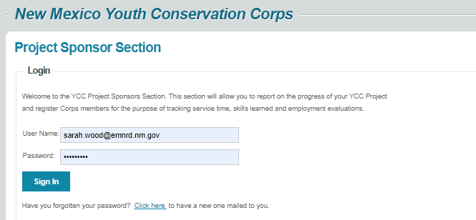

Scroll down to the Projects section and click on your current project. If you've had several YCC projects, your current project will be listed last. If you can't see your projects, contact YCC and we'll sort it out.

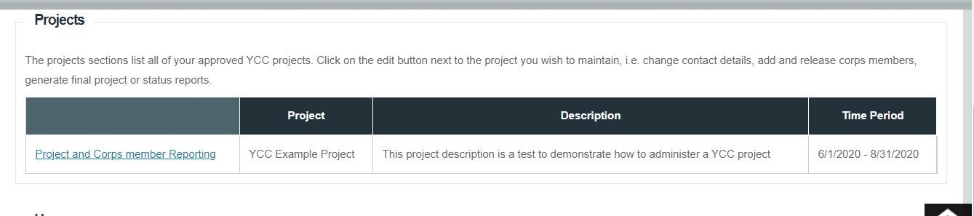

Scroll down to the Corps Member Positions section.

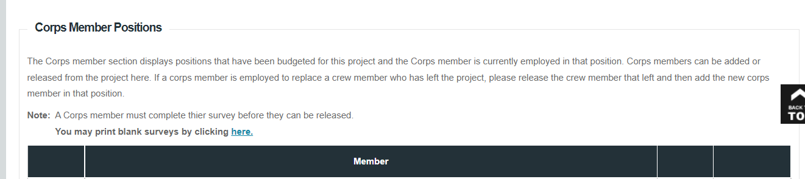

Click on the "Add Corps Member" link. 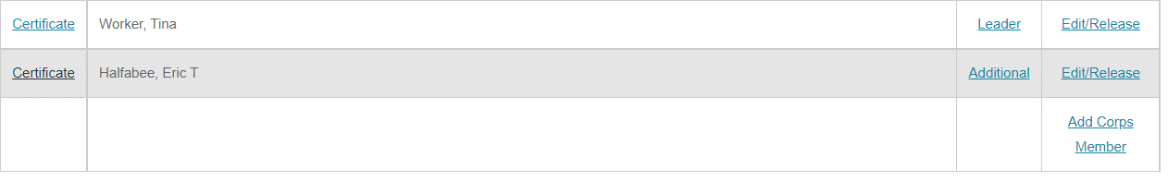
On the next screen enter the corps member's first and last name and press the Add button.
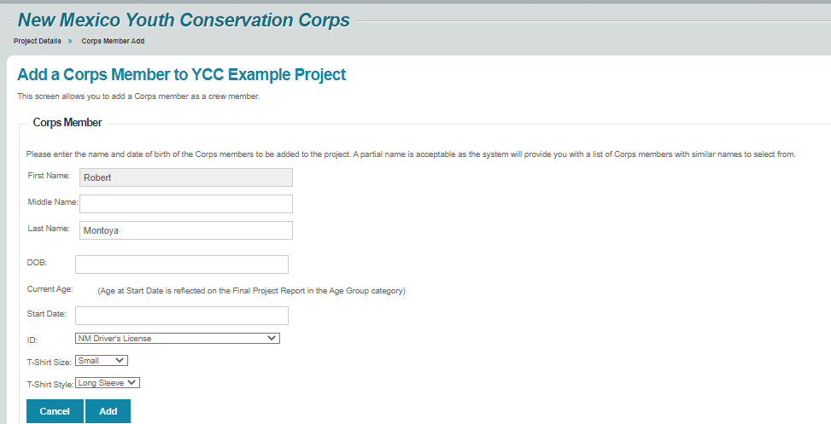

If the corps member has the same name as a corps member in the system, a screen will pop up with the title Existing Corps Member. If the information on this screen matches your corps member's information, press Add and the corps member will be added to your project.

If this person is not your corps member, click the Next button until you find the correct person

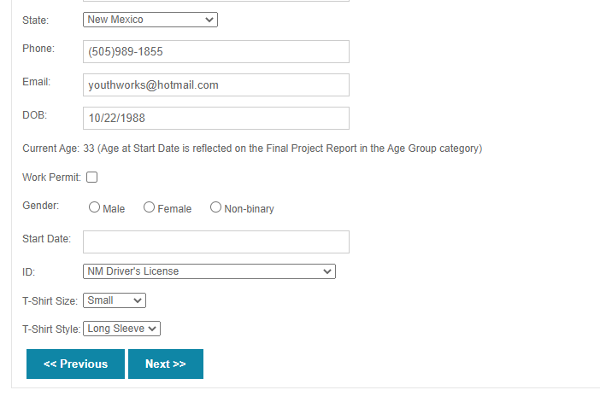
OR reach a screen called New Corps Member. Here, enter the corps member's address, phone, e-mail. NOTE: it is important to include a long-term valid e-mail for each corps member so that the YCC can notify corps members regarding their benefits.

Press Add and the corps member will be added to your project.

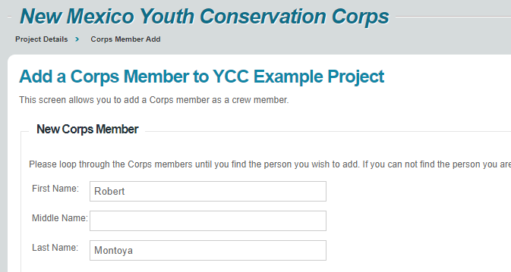

On the next screen, select the "Certificate of Eligibility" option.

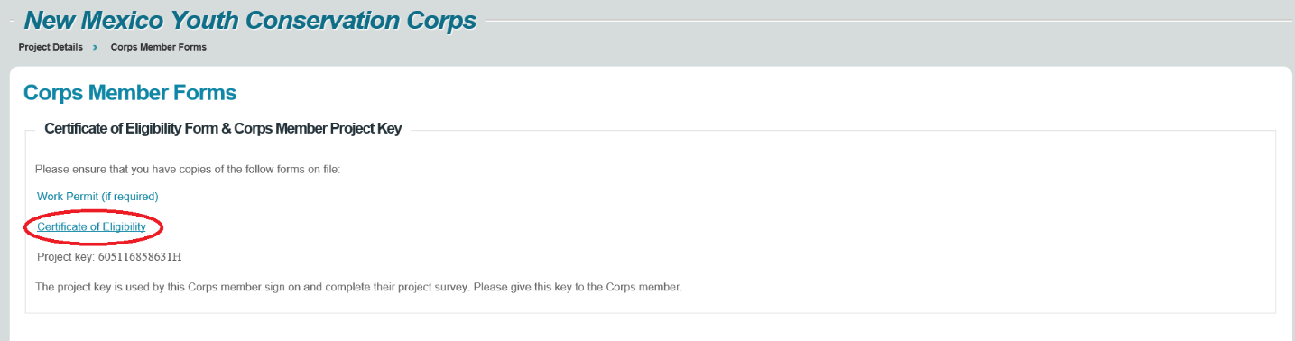

Print the Certificate of Eligibility or save it electronically as a PDF and keep with the employee's file. The corps member's project key printed at the bottom of the page is the corps member's login for their survey at the end of the project.
Press the blue Return link at the top right.

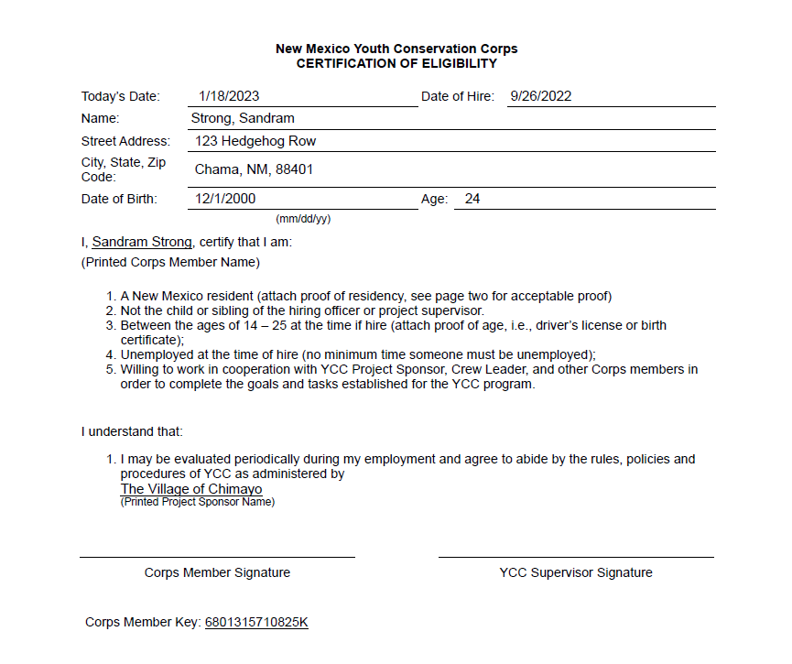
This will take you back to the screen below; press "Project Details" to add another corps member.

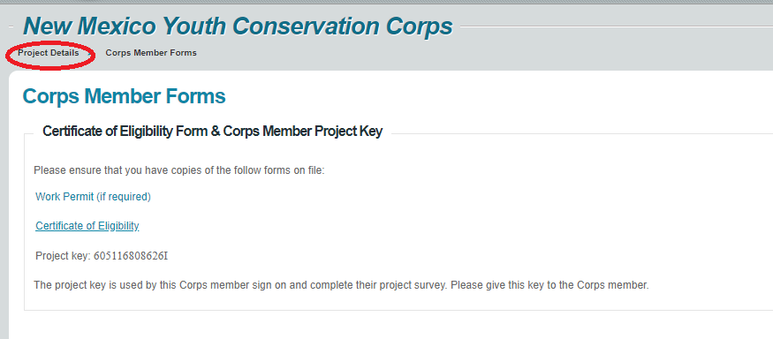
You may also print the Certificate of Eligibility from the list of corps members. Please also assign a 'Leader', 'Trainer' or 'Member' role to the corps member.

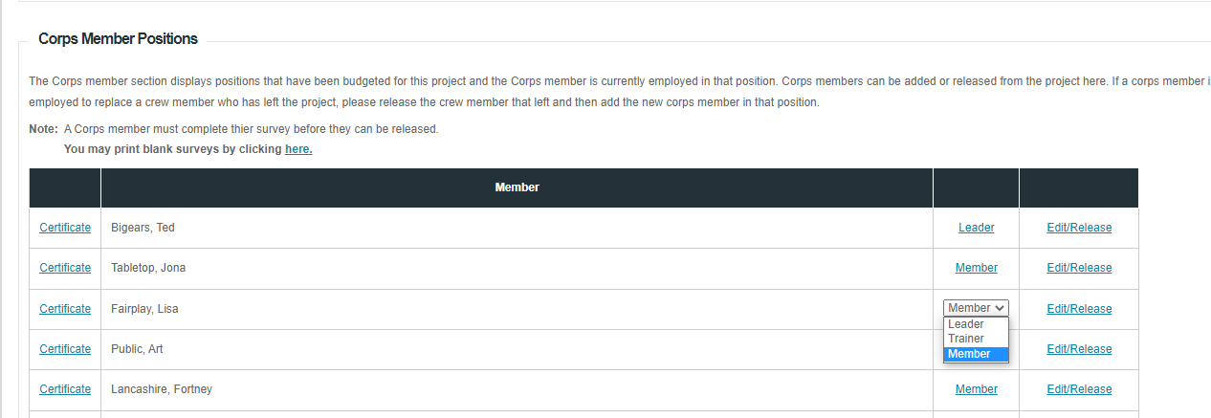

REIMBURSEMENT PACKET INSTRUCTIONS
Sponsors must use their own funds to pay for project expenses, following their approved cost proposal in Attachment 1 of their Agreement. Except for the period ending June 30, there are no hard deadlines. Most sponsors submit reimbursements about once every two pay periods.

Reimbursement packets must be printed out and mailed to the address below. DO NOT EMAIL.
Youth Conservation Corps
1220 South St. Francis
Santa Fe, NM 87505

There are six parts to a YCC reimbursement: the Invoice, Corps Member wages, Other costs, Offeror Contribution, Project Status Report and Photos.

SECTION 1: INVOICE
The Invoice for Reimbursement workbook has your project budget pre-loaded. Ten invoices are provided, please use in sequence. Fill in the fields highlighted yellow and submit as the cover sheet of your reimbursement packet. The workbook automatically tracks your budget, contribution and number of weeks worked with every invoice.

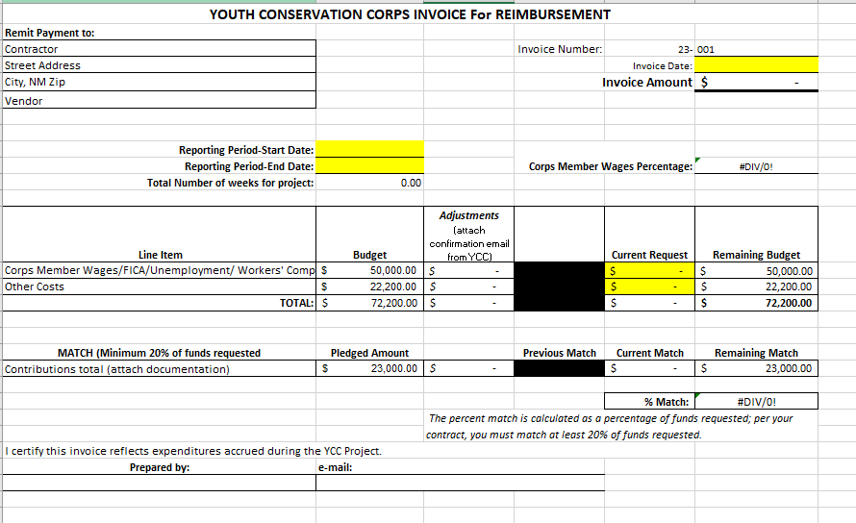

SECTION 2: Corps Member Wages
Prepare a summary spreadsheet with all corps member names, hours worked and FICA / Unemployment insurance / Workers Comp percentage. The YCC reimbursement worksheet automatically totals payment per corps member. If your payroll register has all this information, you may use that. Example below:
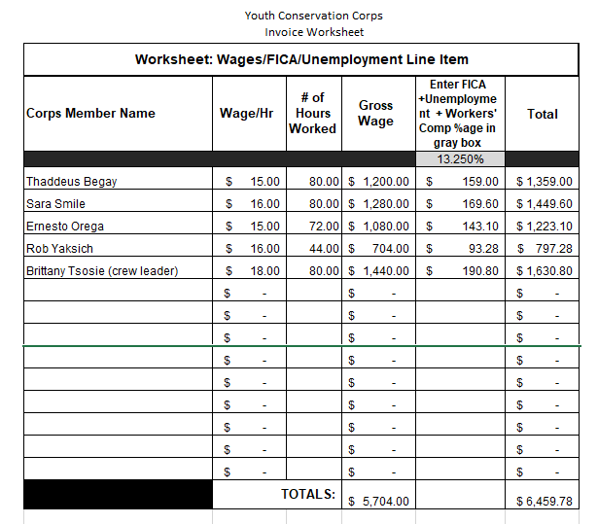

Include as supporting documentation:
- Copies of Corps members’ cancelled checks or pay stubs OR the direct deposit print-out.
- Timesheets if the paystubs do not reflect dates and hours worked.
Enter the total in the Current Request Column of the “Corps member wages” line item of the YCC invoice. In this example, that would be $6,459.78.

SECTION 3: Other Costs (Supplies, Training, Staff, Admin, Mileage)
Enter a brief but specific description for each item in the cover summary sheet that matches what is in your cost proposal and how it supports your project. See examples below.

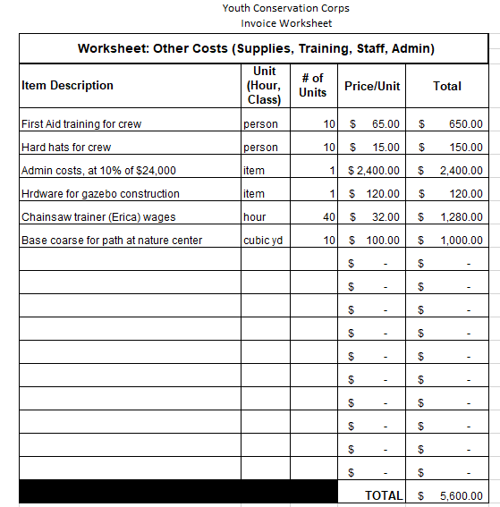

For each line include the following supporting documentation as appropriate:
- Invoices or receipts
  - Legible, clearly dated and with the business name and address printed on them.
  - Descriptions and quantities of each item
  - Copied on to a sheet of 8 1/2" x 11" paper if invoices are small. More than one receipt may be copied to one piece of paper.
  - Time sheets for staff.

- Proof of payment for each item which may include
  - Purchase order (for government entities)
  - Copy of a payment voucher (for government entities)
  - Copy of a cancelled check or check register or credit card statement (non-profits)
  - Copies of checks or pay stubs OR the direct deposit print-out for staff or trainer time.
  - Proof of payment not required for fuel, ice, food; receipts are enough
  - If claiming admin time, please include calculations that are consistent with your approved proposal.

- Vehicle usage form. Include this form if you have requested mileage reimbursement in your approved proposal. Submit it with your reimbursement and add the expense to the “Other Costs” line item. If you have reimbursed a driver of a non-company vehicle, you will have to submit proof of payment.

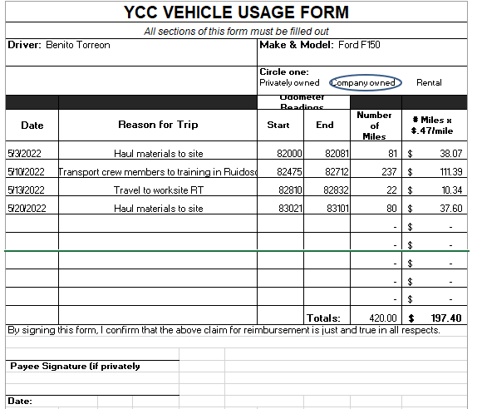
Enter the total for “Other Costs” in the second line of the “Current request” column in the invoice. In this example, that would be $5,600 + $197.40 = $5,797.40.

SECTION 4: Offeror Contribution
All items that are claimed as a contribution must have the same type of supporting documentation as those for Other Costs. Enter the total contribution amount under "Current Match" on the invoice. The invoice automatically tracks the percentage contribution as a function of the funds requested.

In the example below, the sponsor would submit invoices or paystubs and timesheets for the trainer and bus driver, volunteer time sheets, and an invoice and proof of payment (voucher or cancelled check) for the lumber.
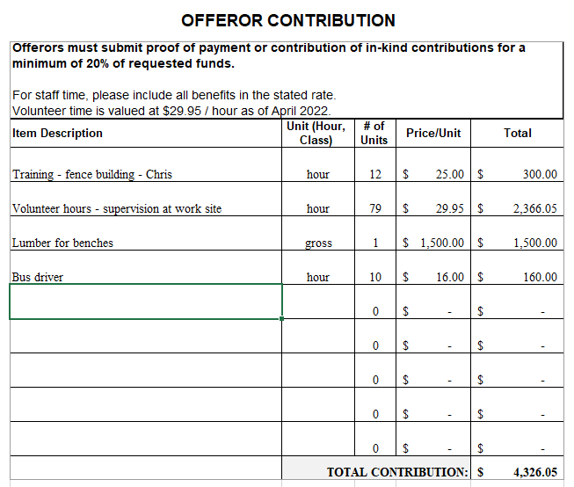

SECTION 5: PROJECT STATUS REPORT
Status reports are entered online. Data is compiled and reported to the Legislature, so they are an important source of information.

Log in to https://wwwapps.emnrd.nm.gov/YCC/YCCPTS/Sponsor/Login.aspx.

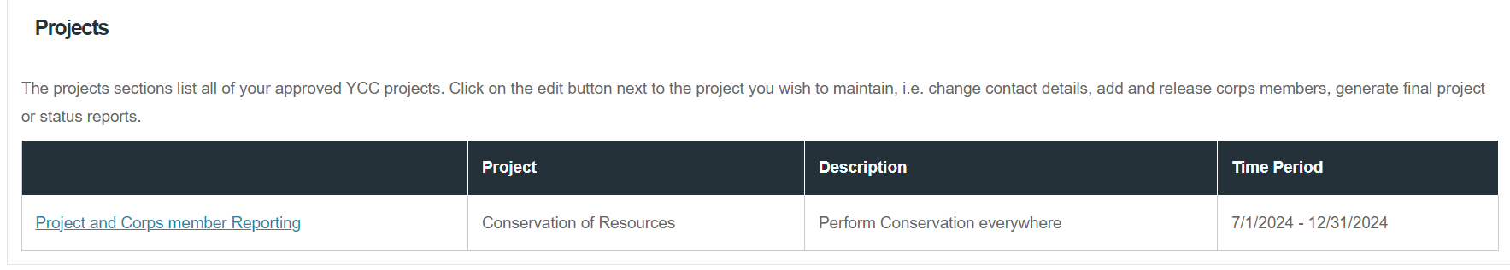
Scroll down to the "Projects" section and select the current project.

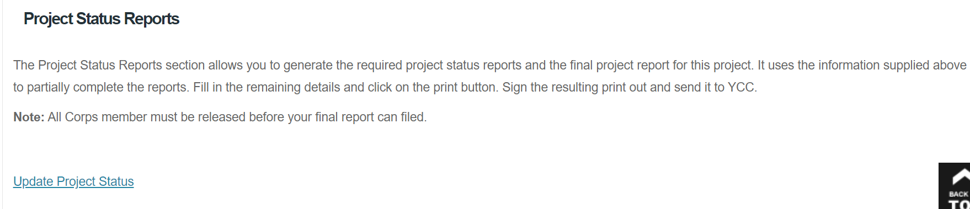
Scroll down to the "Projects Status Reports" section and click Update Project Status
Enter the hours worked in the period you are reporting for in the “Additional Hours Paid”. In this example, 10 corps members worked 50 hours each.
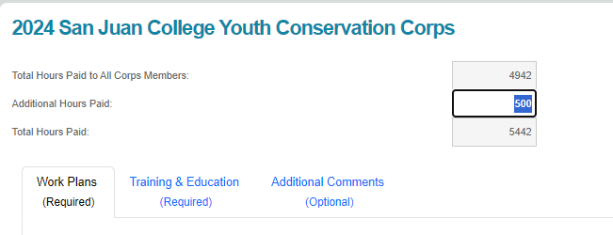

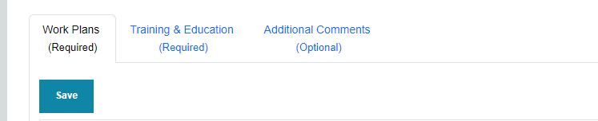
Work Plans tab: This section will have the names of your work plans and three status options for each plan: In Progress, Completed and Request for Cancellation.

The default is “in progress”.
Add notes to the text box and press Save.
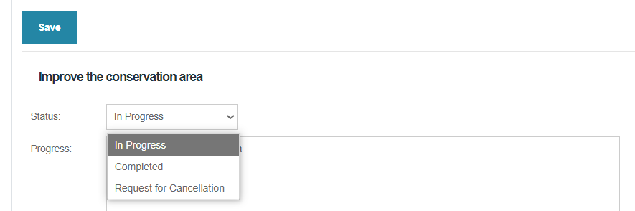

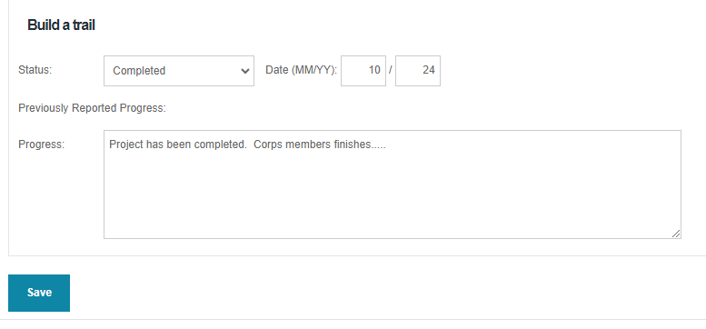
Select “Completed” when the work plan is done. Enter the month and year of completion, and any additional notes on the project. All progress notes will be saved and carried over to the project inspection.

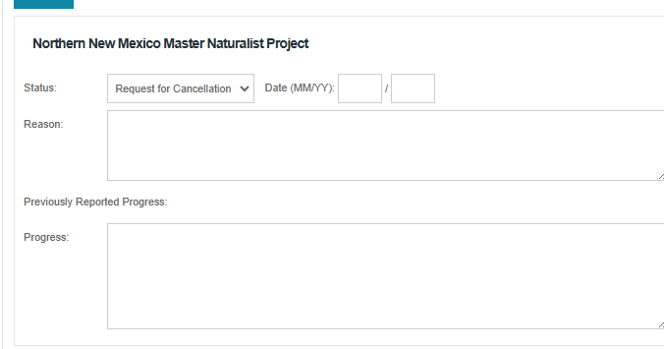
Select “Request for Cancellation” if you cannot complete a work plan. Enter the month and year and a detailed justification. YCC staff will follow up with you.

SAVE your work before moving on to the next tab! Save buttons are at the top and bottom of the page.
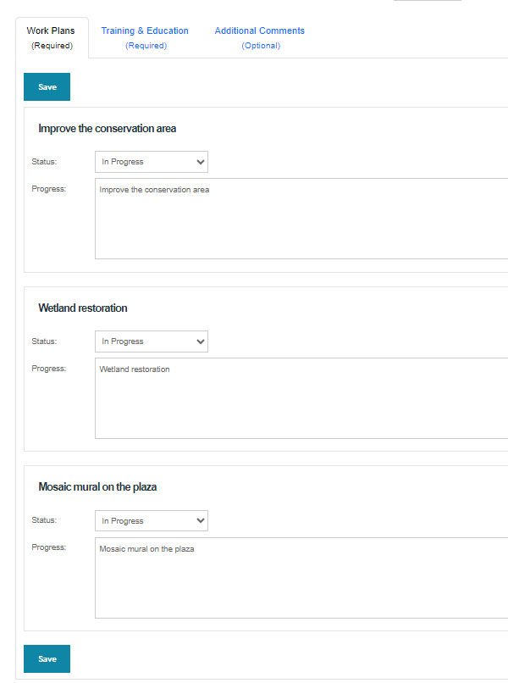
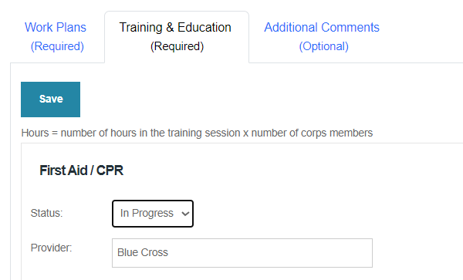
Training and Education: This section has the names of your training sessions and three status options for each: In Progress, Completed and Request for Cancellation. The default is “in progress” and is for trainings that have not been given yet.

Select Completed and enter the month and year when a training is done. Hours = number of corps members x hours of training. Example: 4 corps members x 5 hours = 20 hours of training.

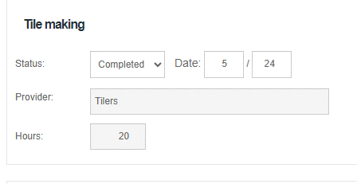

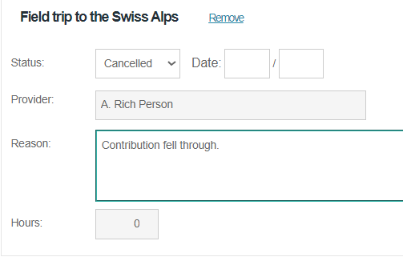
Select Cancelled if a training is not given, and enter the month and year. Provide a reason the training did not occur.

If you’ve provided additional training, scroll to the bottom, press the “Add New Session” button, and enter the name of the training and the provider. SAVE before exiting this section.
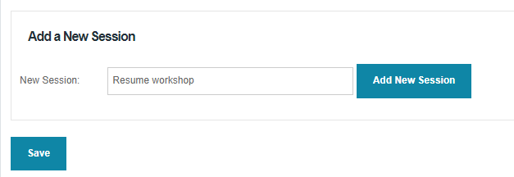

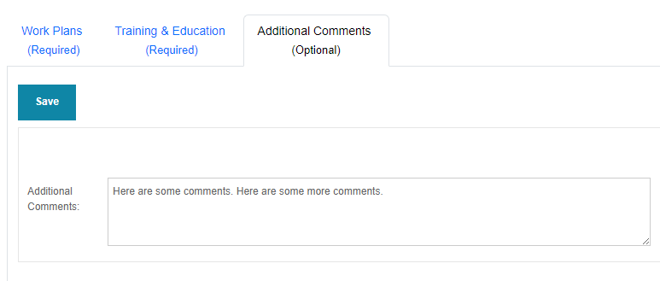
The final tab, Additional Comments, is optional. Here you may enter any additional information you would like. This information will become part of the project file

SECTION 6: PHOTOS
The YCC requires at least two photos of the project with each reimbursement. Photos should be at least 1MB in size, show corps members engaged in a project or event, and the YCC logo (shirts or sticker). Ensure all corps members appearing in the photos have a photo release form on file, as required by your Agreement.

E-mail to sarah.wood@emnrd.nm.gov , morganl.tolen@emnrd.nm.gov, upload to YCC’s Google Drive at https://photos.app.goo.gl/tRUm8KKmruB2SW3D6 or tag us on social media, see our handles below.

Instagram: @nmyouthcorps
Facebook: NewMexicoYouthConservationCorps
X: @NMYouthCorps

JUNE 30 DEADLINE
All Sponsors should plan to submit a reimbursement packet that includes all expenses up to and including June 30. This is the end of the state’s fiscal year. The reimbursement packet needs to arrive at the YCC office by JULY 15.

If a pay period straddles June 30, submit timesheets and wage calculations for days worked up to June 30, even though you may not have paid the Corps member for those days of work. Proof of payment may be included with the next reimbursement.

If an expense straddles the fiscal year (e.g. a rental vehicle), please obtain an invoice up to June 30 and submit with your reimbursement OR calculate the cost up to June 30 and include those calculations in your reimbursement packet.

Requisitions or purchase orders for services and supplies that are created before June 30 must be delivered, invoiced, and paid for before June 30. The invoices must be included with the FY End reimbursement. YCC will not accept invoices dated before or on June 30 past the July 15 deadline.

PROJECT CLOSE-OUT

There are five steps to closing out the project.
- Corps members complete a brief online survey. Make completing the survey part of every corps member's last day.
- Sponsor completes a Status Report.
- Sponsor releases the Corps member using https://wwwapps.emnrd.nm.gov/YCC/YCCPTS/Sponsor/Login.aspx
- Sponsor completes a Final Project Report in the online portal.
- The Sponsor prepares and submits the final reimbursement packet within 45 days after completion of the Project.

Corps Member Online Survey
Each Corps member is assigned a project key that enables them to access the survey. The project key is printed at the bottom of the Certificate of Eligibility Form. The only letter in the key is the very last digit.


To access the survey online, Corps members should go to:
https://www.emnrd.nm.gov/about-ycc/for-ycc-corps-members/
and click on online survey:

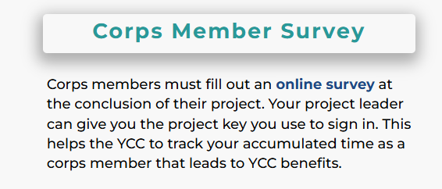

The log-in page asks the corps member to enter their Project Key, which is printed at the bottom of the Certificate of Eligibility.

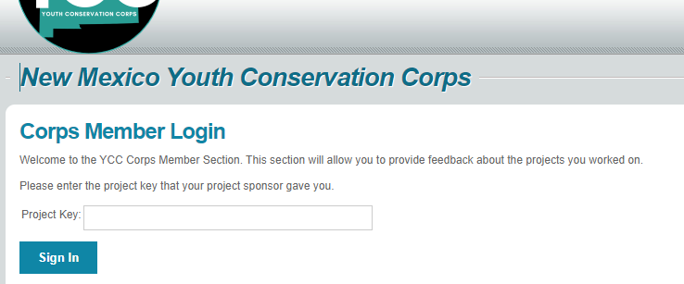

The corps member completes the survey and presses Submit/Print Survey. The screenshots below show the beginning and the end of the survey.

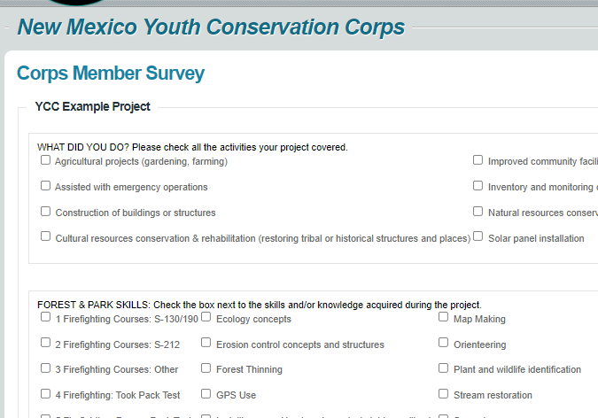

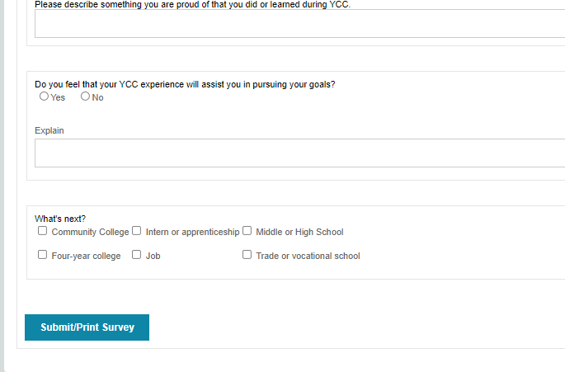

Print Alternative: You can print the survey (see screenshot below) from the Corps Member positions section of the project sponsor portal so corps members can complete it on paper. You will still have to enter it into the database using their project key.
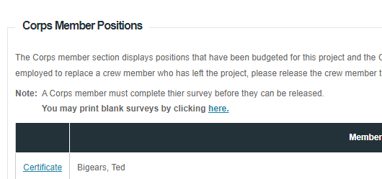

Status Report
Sponsor shall complete a Status Report that covers all the time up to the end of the project. Project Status Reports are a major source of information that YCC uses to report to the legislature. Do not skip this step. This is not the same as a Final Project Report.

Release the Corps Members from the Project
You will be able to release corps members after they have completed the survey.

Log onto the Project Reporting Site from
https://wwwapps.emnrd.nm.gov/YCC/YCCPTS/Sponsor/Login.aspx

Scroll down to the "Projects" section and select the current project.
Scroll down the Corps Member section; select the Edit/Release option:
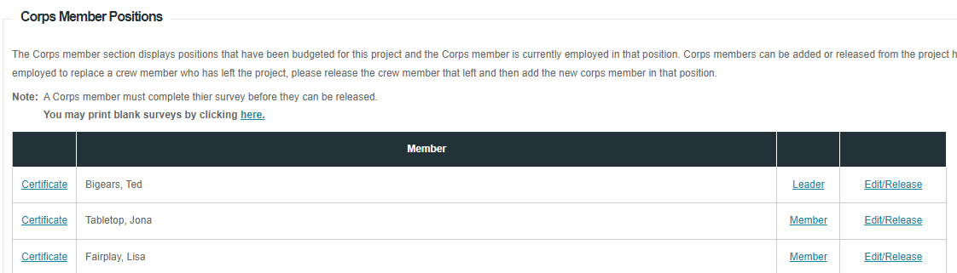

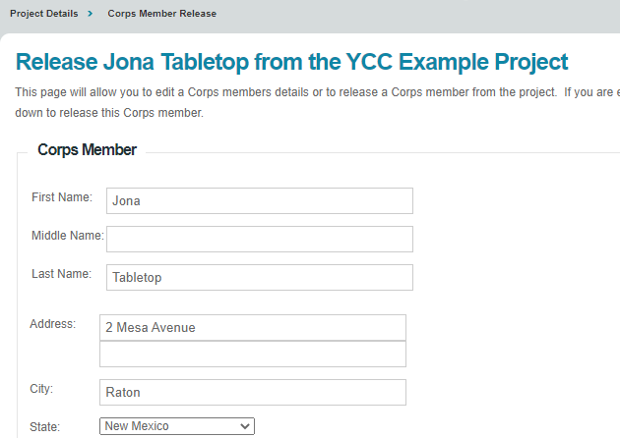

Complete each section to release the corps member:

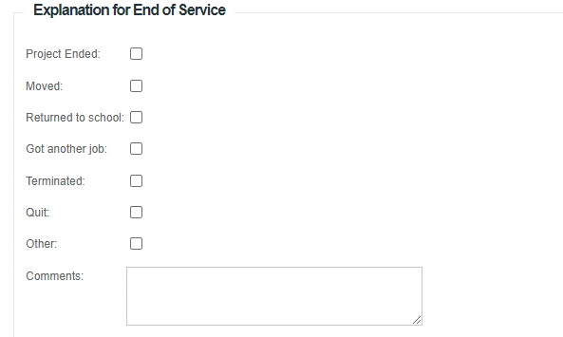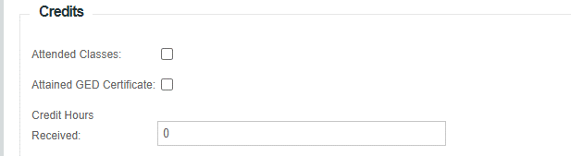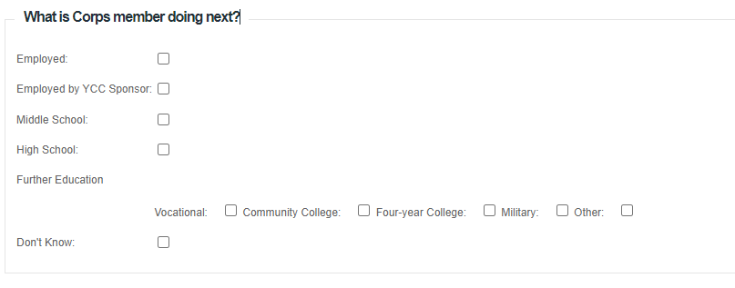

The final section is the evaluation. An Unsatisfactory evaluation will not count towards YCC service for corps members benefits.
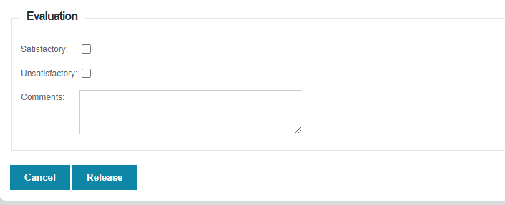

If you try to release a corps member before they have done their survey, you will get an error. Press cancel and have the corps member do the survey or call the YCC if a member cannot complete the survey.

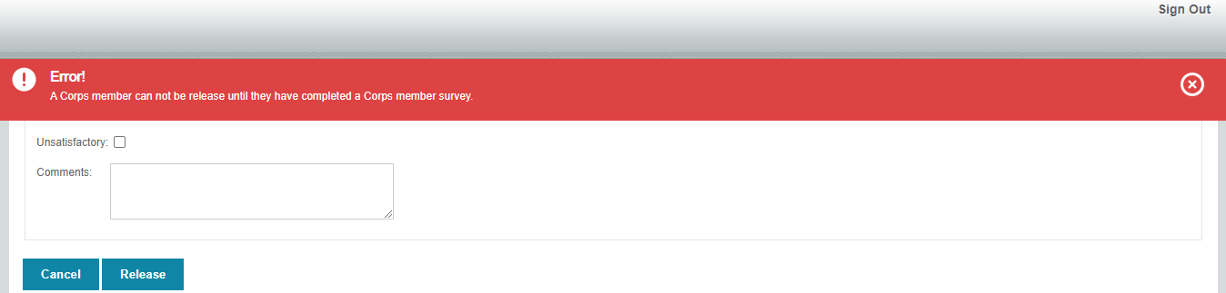

Accessing the Final Report

After all corps members are released, the Final Report link will appear at the bottom of the Project Details page when you log into https://wwwapps.emnrd.nm.gov/YCC/YCCPTS/Sponsor/Login.aspx

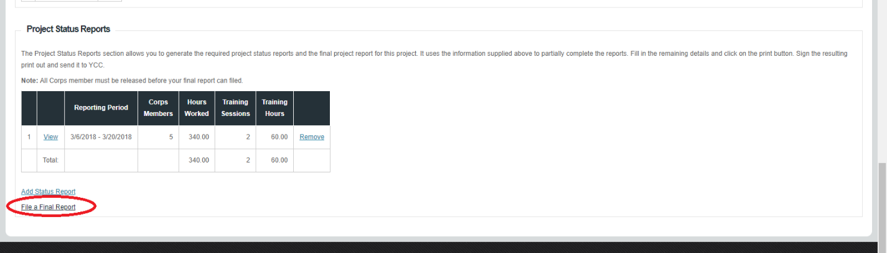

Most fields of the Final Report will automatically be filled in. You will be asked to do a short summary of the project.
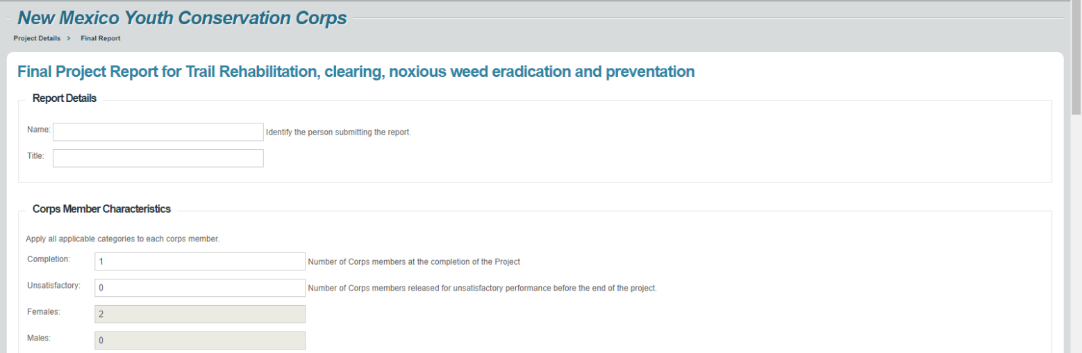

Print, sign and submit with the Final Reimbursement

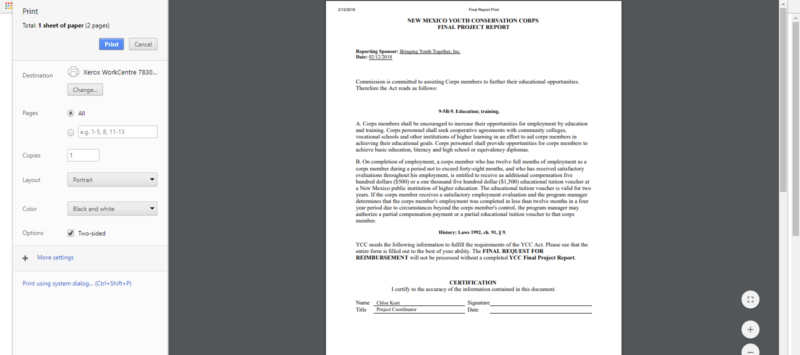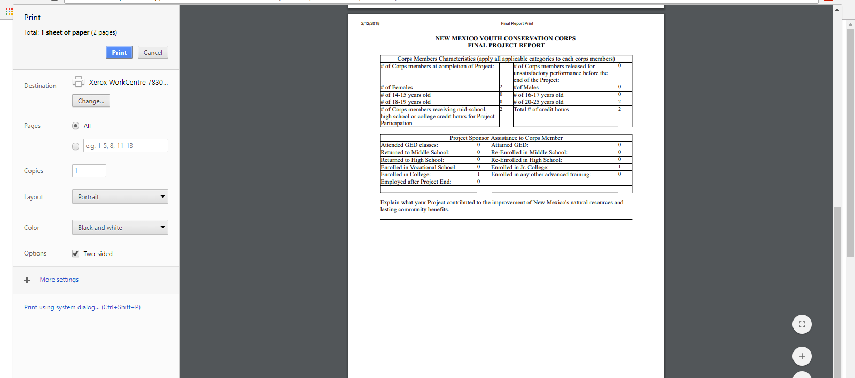

Submit a Final Reimbursement
Prepare and submit the final reimbursement packet within 45 days after completion of the Project. This packet is prepared in the same manner as the previous reimbursement packets except that both a Status Report and a Final Project Report are submitted.

SITE INSPECTION and FILE AUDIT
YCC will perform a site inspection and file audit. This consists of visiting work project locations and reviewing project files, particularly corps member files. YCC will notify the Sponsor prior to the visit to set up times and locations.

Sponsors should keep the following information in a YCC project file:
- YCC job announcements and advertisements
- Corps member applications and resumes
- Interview Information and selection criteria
- YCC Contract & Correspondence
- Reimbursement documents.
- Contribution documents.
- Personnel Files
  - YCC Certificate of Eligibility
  - I-9
  - W-4
  - Proof of New Mexico Residency
  - Proof of age
  - Work permit if corps member is age 14 or 15.

CORPS MEMBER BENEFITS
The Youth Conservation Corps (YCC) Commission offers a $1,500 educational tuition voucher OR a $500 cash compensation to YCC corps members who have worked on a YCC project for 12 months (48 weeks) within a 48-month period (4 years). The YCC Commission may offer a prorated amount based on a minimum of 32 weeks worked; however, this may be limited by our budget.
The YCC will contact corps members and their sponsors at the conclusion of every project to inform them of their eligibility and provide the necessary information. It is important to include a valid e-mail when entering corps members into our database.
Cash reimbursement
Corps members who opt to receive the cash compensation will receive one lump-sum payment.

Educational voucher
The educational voucher is good for reimbursement of expenses at a New Mexico institution of higher education, including on-line education, associated with an accredited New Mexico institution of higher education or vocational training. The voucher is valid for two years and expenses will be reimbursed upon when valid receipts are sent to us.

Expenses the YCC will reimburse include: tuition, fees, software, textbooks, calculators, lab supplies and classroom supplies such as paper, toner cartridges, and other similar items.

Expenses the YCC will NOT reimburse include: personal expenses, transportation, computers, residential rent, and food.

APPENDIX A: Links to I-9 Instructions in English & Spanish
Page of
(Click to go back to corps members section)

If these links don’t work, let us know.

Or visit:

I-9, Employment Eligibility Verification (uscis.gov)
i9-INS-Spanish.pdf (uscis.gov)
Page of

APPENDIX B: New Mexico Proof of Residency Documents
Page of

(Click to go back to corps members section)
Reference: 18.19.5.16.D New Mexico Administrative Code

Please note passports, birth certificates and baptism certificates are not proof of New Mexico residency.

- A valid New Mexico driver's license
- A valid New Mexico ID card or
- A current real property rental agreement or purchase agreement
- A utility bill dated within 60 days, such as water, gas, electric, waste, telephone, cable, or satellite bill, but not a bill for a cell phone
- An insurance bill, card, or binder, dated within the past 6 months
- A bank or credit card statement dated within 60 days that contains the corps member’s name and address
- An employment pay stub, dated within 60 days that contains the corps member’s name and address
- A current, local property tax statement or mortgage documents
- A document from an education institution, such as a transcript, report card or enrollment confirmation, that contains the corps member’s name and address and is dated within 60 days
- Original documents from a city, county, state, tribal or federal government organization attesting to the fact that the corps member is a New Mexico resident
- A New Mexico medical assistance card with address on card, letter from issuing agency that came with card showing name and address, or profile printout from issuing agency
- A New Mexico public assistance card with address on card, letter from issuing agency that came with card showing name and address, or profile printout from issuing agency
- Documents acceptable for corps members less than 18 years of age:
- Documents indicating membership in a New Mexico religious organization
- Documents indicating membership in a New Mexico sports organization,
- Two proofs of New Mexico residency of the parent/guardian and an affidavit from the corps member’s parent or guardian stating that the corps member lives with that person
- A New Mexico medical or public assistance card, profile printout or a letter from the issuing agency
- A document evidencing eligibility and proof that the corps member's parent or guardian is currently receiving services from a non-profit organization qualified pursuant to Section 501(c)(3) of the Federal Internal Revenue Code of 1986 provided the document displays the corps member’s address.

APPENDIX C: Child Labor Laws in New Mexico

(Click here to go back to corps members section)

ARTICLE 6
Employment of Children

50-6-1. Children under fourteen; employment prohibited.
No child under fourteen years of age shall be employed or permitted to labor at any gainful occupation unless otherwise provided for in the Child Labor Act [Chapter 50, Article 6 NMSA 1978].

50-6-1.1. Short title.
Chapter 50, Article 6 NMSA 1978 may be cited as the "Child Labor Act".

50-6-2. Work permit for children fourteen to sixteen.
A child over the age of fourteen years and under the age of sixteen years shall not be employed or permitted to labor at any gainful occupation without procuring and filing a work permit unless otherwise provided for in the Child Labor Act.

50-6-3. Maximum hours for children fourteen to sixteen.
A. Children over the age of fourteen and under the age of sixteen years shall not be employed or permitted to labor at any gainful occupation for more than forty hours in any one week nor more than eight hours in any one day when school is not in session unless otherwise provided for in the Child Labor Act.
B. Children over the age of fourteen or under the age of sixteen shall not be employed unless otherwise provided for in the Child Labor Act:
(1) before 7:00 a.m. or after 7:00 p.m. during the calendar school year;
(2) before 7:00 a.m. or after 9:00 p.m. outside of the calendar school year;
(3) during school hours, except as provided for in work experience and career exploration programs;
(4) more than three hours per day during school days; or
(5) more than eighteen hours per week during school weeks.

50-6-4. Prohibited occupations for children under sixteen; exceptions.

A. A child under the age of sixteen years shall not be employed or permitted to labor at any of the following occupations or in any of the following positions:
(1) on or around belted machines while in motion;
(2) on or around power-driven woodworking machines used for cutting, shaping, forming, surfacing, nailing, stapling, wire stitching, fastening or otherwise assembling, processing or printing wood or veneer;
(3) on or around power-driven hoisting apparatus with the exception that this section shall not prohibit the operation of an automatic elevator that is controlled by pushbuttons making leveling, holding, opening and closing of the car and hoistway doors entirely automatic;
(4) in or about plants, establishments or jobs using, manufacturing or storing explosives or articles containing explosive components;
(5) electronics jobs where the child is exposed to electrical hazards;
(6) in or about any establishment where malt or alcoholic beverages are manufactured, packed, wrapped or bottled;
(7) municipal firefighting whether using volunteers or paid employees;
(8) manufacture of goods for immoral purposes;
(9) in any employment dangerous to lives and limbs or injurious to the health or morals of children under the age of sixteen years; or
(10) soliciting door-to-door for other than a nonprofit organization or in other activities approved by the parent or guardian.
B. The provisions of this section do not apply to:
(1) children engaged in working with equipment in any school or place where cooperative education or science is taught while under supervision of an instructor;
(2) apprentices while under the supervision of a journeyman in a certified apprenticeship program; or
(3) children employed in a film or television production, where the set may be considered physically hazardous or special effects are used; provided that a New Mexico-certified trainer or technician accredited in a United States department of labor occupational safety and health administration-certified safety program specific to the film or television industry is present at all times that the child is exposed to the potentially hazardous condition.
C. Additional hazardous occupations not specifically listed in this section shall be determined by the state child labor inspector following consultation with the employer who wishes to employ minors over the age of fourteen years and under sixteen years of age.

50-6-5. Prohibited occupations for children under eighteen.
No child under the age of eighteen years shall be employed or permitted to labor in any mine or quarry underground or at or about any place where explosives are used. However, children under the age of eighteen years but not under the age of fourteen years may be employed to separate mica if blasting is done during periods when there is nobody working, and the mica is subsequently removed from the blasting area to another site for operation.

50-6-7. Work permit; issuance; authorized officials; application; contents; proof; copies; maximum term.
A. Work permits shall be issued only by the school superintendents, school principals, designated issuing school officers or the director of the labor and industrial division of the labor department or the director's designee.
B. A work permit shall not be issued to a child until satisfactory proof has been furnished that the work in which the child is to engage is not dangerous to the child or injurious to the child's health or morals.
C. The application for the work permit shall show that the work to be performed would not result in injury to the health, morals or mental development of the child. Satisfactory proof of the age of the child at the date of the application shall be furnished. Any application for the employment of children at any gainful occupation during the session hours of the school of the district in which the child resides shall set forth, in addition to the foregoing, the necessity to the family or the dependents of the child or for the child's own support of the income to be derived from the employment or labor.
D. Whenever the person authorized to issue the work permit is satisfied that the provisions of this section have been complied with, the person shall issue to the child a work permit, keeping one copy on file and sending one copy of the permit to the labor and industrial division of the labor department.
E. No work permit shall be in force without renewal for a longer period than one year from the date of issuance.

50-6-8. Renewal of work permits.
The officer authorized to issue work permits may renew a work permit at the expiration date thereof for a period not exceeding one year upon a satisfactory showing upon the part of the child, the child's parent, guardian or custodian that the provisions of the Child Labor Act are being complied with and that the child is in good health. The extension of time shall be made by the officer writing upon the certificate the following words: "this work permit is extended for a period of ...... days from this date" and by the officer signing the certificate.

50-6-9. Employer's records; form of permits.
Whenever any child is employed or permitted to labor at any gainful occupation permitted by the laws of this state, the employer of the child shall preserve on file the work permit of the child and shall keep posted in a conspicuous place about the premises where the child is employed a list of all children there at work by virtue of work permits. The form for all work permits shall be prepared by and shall contain such information concerning the identity of the child as may be prescribed by the labor and industrial division of the labor department.

50-6-10. Inspection of work permits, records and premises by the labor and industrial division of the labor department.
All work permits and records and the premises where children are employed are subject to inspection by representatives of the labor and industrial division of the labor department. The director of the division may, for cause, cancel a work permit with the concurrence of the officer issuing the permit but, in case they disagree, the district court may cancel the permit on complaint setting forth the grounds therefor under the provisions of the Child Labor Act.

50-6-11. [Habitual presence of child under sixteen at a place of work during school hours; prima facie evidence of employment.]
The frequent presence of any child under sixteen years of age, during school hours, at any place where workers are at work more or less habitually shall be prima facie evidence that such child is unlawfully engaged in labor, if no permit is exhibited.

50-6-12. Penalties.
A. A person who employs a child, or who is the parent, guardian or custodian of a child, and who permits that child to be employed in violation of any of the provisions of the Child Labor Act is guilty of a petty misdemeanor. Each violation of the Child Labor Act constitutes a separate offense. A second or subsequent conviction of an employer, parent, guardian or custodian for violation of the Child Labor Act is a misdemeanor.
B. The director of the labor and industrial division of the labor department may report a violation of the Child Labor Act to the local district attorney, who may prosecute the alleged violator.

50-6-13. District court jurisdiction.
The district courts are hereby given original jurisdiction in all cases of violations of the provisions of the Child Labor Act.

